,l
Progynist

Performance Report for BoD Meeting

(January 1, 2024 – July 31, 2024)

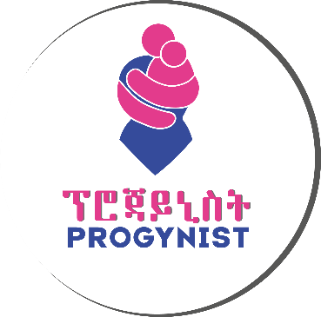

Program I
Habitat for Humanity Ethiopia (HFHE) - Empowerment for Vulnerable Communities through Integrated Slum Area Development

Executive Summary
Habitat for Humanity has been following the mission of providing poor households with decent housing for many years in the past. Women-headed residents of Akaki Kality Sub City Woreda 3, Lideta Sub City Woreda 5, and Gulele Sub City Woreda 1 were among the many families in Addis Ababa supported by HFHE.
Nevertheless, HFHE believed that the provision of housing by itself does not bring food to the table for the beneficiaries of the project. Therefore, engaging women in some form of income generation would help the households cover their necessities.
HFHE sent out expression of Interest to select NGOs who are experienced in organizing women groups into income generation schemes. Progynist was selected to carry out this project entitled "Empowerment for Vulnerable Communities through Integrated Slum Area Development". Progynist was selected after a thorough due diligence process by Habitat.
The collaborative operation between Progynist and Habitat could not run at the expected speed due to the time taken to explain the need for this collaboration to the sub-cities that were partners in the construction of the housing project. It took back-and-forth communications and lengthy discussions after which HFHE got the approval.

Project Name | Period of Activity | Annual Budget (ETB) | Program Status | Project site/s
Empowerment for Vulnerable Communities through Integrated slum Area Development | February 10, 2023 - May 31, 2024 | 2,933,653.60 | Completed | Addis Ababa  - Akaki Kality Sub city, Woreda 3  - Lideta Sub city, Woreda 5 and  - Gulele Sub city Woreda 1

Program Description
Habitat in collaboration with Progynist intended to build the social and economic capacity of women who have benefited from the residential schemes designed by Habitat.
The implementation period of the project was agreed to start from February 10, 2023, to May 31, 2024. A total budget of Birr 2,933,653.60 was allocated for its implementation. After the agreement, the budget took some time without being released at the intended time. The first trench which is 20% of the total budget allocated for the project, Birr 586,730.78 was released on March 30, 2023, for project initiation. The budget was not released according to the time frame of the project, which delayed the implementation to some extent.

Goals & Objectives
Habitat and Progynist signed a memorandum of understanding with the following objectives: -
- To assist selected 100 unemployed women to learn to solve their problems by themselves
- To build their capacity on how to establish a small business
- To work towards the creation of enabling environment by linking them to public and private sector operators who can provide them with appropriate services
- To share experiences and disseminate best practices with and to interested parties respectively.

Implementation Strategies
  - Gender Transformation Approach
  - Engagement
  - Women Empowerment
  - Linkage and Collaborative Relationships among Stakeholders
  - Advocacy/Campaigns

Program Performance
The strategy followed was for Progynist to take the lead in the implementation of the project but to ensure sustainability by involving a financial institution after the phase-out of the project.
Activity 1: Monitoring and evaluation was conducted
- As part of the project implementation, monitoring activities were carried out using various monitoring methods, mainly focused on using written questionnaires, interviewing project beneficiaries, and monitoring performance.
- A series of evaluation and monitoring activities were conducted in all three Woredas. Through this monitoring activity, it was possible to observe the efforts of the beneficiaries of the project to improve their own and their families' lives by using the loan services they received.
Activity 2: Project Closeout was conducted
- A half-day project program was conducted.
- A consensus was reached between all three project implementing parties that an exit strategy was needed to continue the project before the project closure.
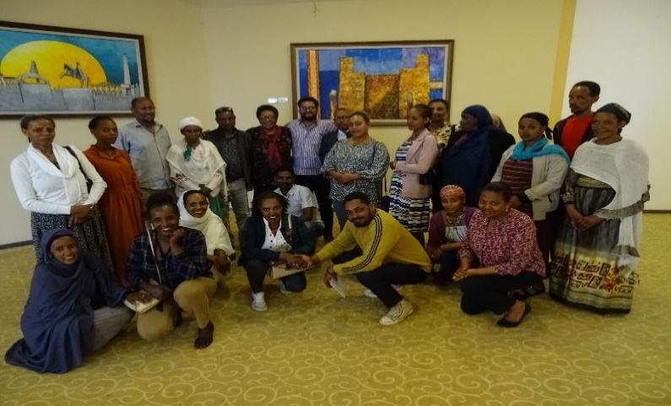
Project Closeout Program
Challenges Encountered
Among the problems we encountered during the implementation of this project are the following:
- The approved loan is not sufficient for the activity we intend to do, some users are not willing to take the loan, so it took time to convince them.
- Delay in response of the Woreda to select and replace new beneficiaries to replace those who refuse to take loans.
- Inadequate budget allocated for the project due to increasing market price inflation.
Lessons learned
- Utilizing internal experts of the implementing organizations to provide the training in quality and save time;
- Providing loan services and utilizing the potential of unemployed women has a multiplier effect on the project's achievements;
- Involving the project stakeholders in the implementation process from the inception stage and providing updated information made them fully engaged in the whole process of implementation;
- The trainees testified that the training has changed their thinking. Therefore, if there is a change in thinking at this level, we have learned that there is a need to strengthen their capacity by preparing similar training in the future;
- When selecting project beneficiaries, it is better to focus mainly on women who have the desire and motivation to work and change, and this not only encourages strong women, but it is also possible to find women who can be role models for others;
- We have realized that the importance of having an organized database by the Woreda creates great potential in terms of saving time, money, and energy to complete the project at the desired time.
Sustainability of the project
A consensus has been reached among the concerned stakeholders that there is a need to plan an exit strategy to maintain the project's sustainability. According to the agreement, it was understood that the following exit strategies of the project should be included in the memorandum of understanding: -
- A memorandum of understanding between Meklit Micro Finance Institution and the Women's Children and Social Affairs Office in all three Woredas will be signed. The MOU will include the roles and responsibilities of each stakeholder.
- The relevant stakeholders in each Woreda will monitor the beneficiaries of the project their activities and solve their problems.
- Each Woreda selects new project beneficiaries and coordinates with the relevant sector offices to provide training as needed.
- Each Woreda will work in coordination with the Meklit Microfinance Institution to facilitate loan services for existing and new project beneficiaries.
- Meklit Microfinance Institution monitors the timely payment of loans of existing project beneficiaries and facilitates access to new credit facilities for users who have completed their loans.
- Meklit Microfinance Institution organizes new project beneficiaries selected from the Woreda into groups and provides professional support to develop a business plan.

Program II
Amplifying Women’s Role in Managing the Devastating Effects of War
Program Description
Project Title | Amplifying Women’s Role in Managing the Devastating Effects of War
Project Intervention Area | Shewa Robit Town Administration, Northern Shewa Zone, Amhara Region
Project Period | 1 Year (February/2024 – February/2025)
Funding Source | UN Women
Implementing Partners | Progynist, Propride, and Emanuel Development Association (EDA)
Total Budget Allocated | Birr 10,894,457.00
Target Beneficiaries | 3,000 women direct beneficiaries, 70% aged between 18-45, and 20,000 indirect beneficiaries

Goals & Objectives
- The overall goal of the project is to ensure that women are empowered enough to participate at all levels of leadership in managing in humanitarian crisis, particularly that of women and girls affected by war.
Objectives:
- To enhance the capability of women to become resilient, peace negotiators, and to defend their human rights in and around Shoa Robit.
- To encourage women to take the lead in creating and strengthening institutions for women survivors of GBV to heal from war-inflicted violence and abuses.
- To effectively improve the economic misfortune of women whose livelihood was turndown by the war.
PROGRAM PERFORMANCE
Activity 1: Staff Recruitment and Personnel Deployment
- Vacancy announcements for three field officers and three social worker positions have been released and the activity of identifying the candidates has been done.
- Written exams and interviews were conducted in the presence of representatives of the three organizations.
- 2 full-time field officers and 3 full-time social workers are recruited for the project.
Activity 2: Provide awareness sessions for newly recruited staff
- Knowledge and understanding created among newly recruited staff on the humanitarian crisis and mechanisms sought.
Activity 3: Organize a half day workshop for 60 representatives drawn from Women and Youth Associations and CBOs, OPD, HIV, Women and Children, Social Affairs, Health, peace and security and Small and Microenterprise Offices to introduce major stakeholders with the objectives, strategies and major Activities of the project to facilitate their engagement in the implementation process.
- The launch program of the project was held in the presence of the relevant stakeholders and all three partner organizations.
- The objective of the program is to create awareness about the objectives, strategies, and main activities of the project. Government bodies, community representatives, and community-based organizations from Deber Berhan and Showa Robit attended the project promotion program.
- In the launching program, a broad explanation focused on the objectives, strategies, and key activities of the project was given, and further, it was shown that the support of all stakeholders is essential for the successful completion of the project.
- After the presentation, a plenary discussion was held to allow participants to share their understanding of the challenges faced by the community members of the intervention area and the contribution of the project.
- The project launch meeting ended on a positive note and all participants expressed their commitment and commitment to the success of the project in addressing the needs of women in challenging situations.
- At the end of the launching program, the project document is signed by the lead organization, Progynist, and government stakeholders

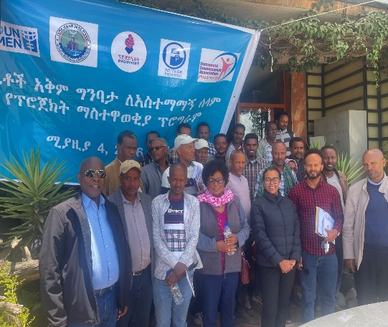
Conducting Project Launching
Activity 4: Provide 2 days of training for 45 representatives of iddirs and other prominent community organizations to facilitate the engagement of men and youth in the protection of women and girls from any violence
- A total of 41 persons, 24 male, and 17 females participated in a two-days workshop to brainstorm on how to engage men in the protection of women and girls during and after war.
- The training influenced Men Iddirs but also representatives from women organizations, school communities, religious institutions, and youth associations.
- The training also highlighted the crucial role of men and youth in creating a culture of respect for women and girls and preventing GBV.
Activity 5: Organize consultative meeting with 30 people representing health facilities, administration and concerned sector offices on the need to respond to physical and mental/emotional health services
The objectives of organizing a consultative meeting with representatives from health facilities, administration, and concerned health sector offices in Shewarobit were to:
- Open a platform for discussion with representatives of health facilities, and concerned sector offices on the content of the project that aims to improve the physical and psychosocial well-being of women affected by war in Shewarobit city administration.
- Increase their participation in support in addressing their physical, psychological, and emotional status of war-affected women in Shewarobit.
- To ask for their contribution in arranging referral and linkage for better health treatment of those war-affected women.

- To discuss and get a preliminary opinion of which drugs are most important and are lacking now in government health facilities.
- A total of 30 participants attended the meeting, 24 men and 6 women.
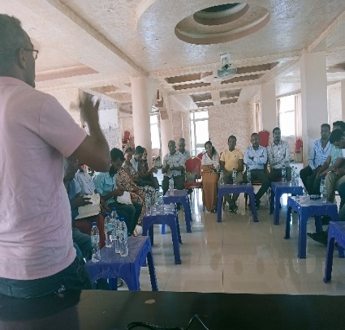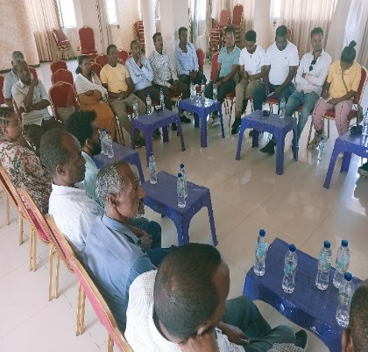
Conducting a consultative meeting
Activity 6: Identify 18 capable young girls and train them for 5 days as community facilitators for women and support groups
The objective of this training was to equip them with the necessary skills and knowledge to effectively train and mentor 18 young girls, with the ultimate goal of turning them into competent community facilitators.
- The topics were covered to enhance the officers' understanding of gender-based violence (GBV) and how to identify and respond to cases of GBV and also equip them with effective methods for communicating with vulnerable women. Additionally, the training delved into the concept of Village Savings and Loans Associations (VSLAs), providing a comprehensive understanding of their function and impact.
- The training included strategies on how to effectively engage and mobilize community members to support and participate in this vital initiative.
- Field staff recruited potential community facilitators who demonstrated the ability and interest to join a VSLA group.
- The selected facilitators took training to further enhance their skills in conducting VSLA meetings, managing team dynamics, and managing financial transactions.
- The training contributed to helping VSLA teams achieve their financial objectives and equip them with the necessary skills of community facilitators.
- With the training given by the community coordinators, a VSLA was established in the nine kebeles in Shewarobit city.
- The support of local administrations in each kebele has been obtained to assist in facilitating the establishment of VSLA.
- Field workers partnered with community volunteers to establish 36 VSLAs with a total of 540 eligible women for the intervention.
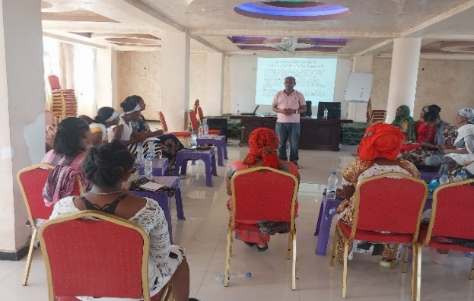
Community Facilitators Training-VSLA
Activity 7: Organize start up workshop with 15 participants drawn from implementing partners organizations for activity and logistics planning,
- A workshop was organized in Debre Berhan city for newly recruited field officers and social workers that focused on the overall project objective, strategy, and key activities of the project.
- The workshop mainly created an understanding of the main objectives of the project as well as creating the capacity to design strategies to successfully implement the project as well as solve problems and challenges encountered during implementation.
- After the workshop, participants expressed their determination to effectively fulfill their roles and responsibilities to achieve the project.
Activity 8: Organizing a two-day dialogue forum to facilitate discussion among 200 community members in Shewarobit town.
The purpose of the forum is to discuss the experiences and challenges of 200 community members to devise ways to solve problems together.
- Sixty-six (98.5%) community members participated in the forum.
- Conducted awareness-raising programs for those affected by war and sexual violence.
- Facilitated discussion sessions using a variety of methods tailored to the needs of the participants.
- Conducted in a way that protects the participants' safety, privacy, and comfort in all discussion forums.
- Conducted reviews and feedback sessions to gather experiences, challenges, and recommendations for future support services.
Challenges Encountered
Challenges:
- Internet shutdowns
- Security concerns – especially interference of the insurgents during training
- Procurement Transparency
Solutions:
- Alternative communication strategies
- Safe meeting locations
- Negotiated for change in procurement policy
Program III: Strengthening Women's Livelihood through sustainable income generation activities
Project Title | Strengthening Women's Livelihood through sustainable income generation activities
Goal of the project | Empower women to become entrepreneurs by developing their skills
Project Intervention Area | Addis Ababa, Yeka Sub City wereda 11 and 12
Project Period | 18 Months (August 1/2024 – January 31, 2026)
Funding Source | Progynist
Implementing Agency | Progynist
Total Budget Allocated | Birr 2,057,682.96
Target Beneficiaries | A total of 50 direct beneficiaries and 300 indirect beneficiaries from two weredas

To implement the project, the following tasks have been accomplished: -
- A joint discussion was held with the heads of the district's women's and children's offices directly connected with the project.
- A project proposal has been prepared and sent to the sub-city for approval.
- A survey was conducted for 50 women selected by the two weredas.

Program IV

USAID/ETHIOPIA Family-Focused HIV prevention, care and treatment services
Executive Summary
Progynist, according to the parameters of the agreement with MJE, has continued to deliver comprehensive OVC mitigation services, primary prevention activities and community HIV care and treatment activities (CHCT) to target groups within two towns of SNNPR, Guraghe zone in Butajira and Hadiya zone in Hosanna and in three towns of SWEPR, Bench-Sheko Zone in Mizan Aman, Sheka zone in Tepi and Kaffa zone in Bonga. The respective achievement of each SNU is presented in the following sections within key MER and Custom indicators as well as each result and intermediate result for the fiscal year to address the needs of 6,838 orphan and vulnerable children of 1,097 KPs and PPs adult care givers in OVC and CHCT activities.
During this performance period, Progynist implemented community-based HIV services program through partnerships with local authorities and by mobilizing community resources to improve the lives of HIV affected orphan and vulnerable children and their adult caregivers. Progynist has also been working towards the enhancement of the response of communities to violations of rights of women and girls by especially addressing gender-based violence.

Acronyms
AGYW Adolescent Girls and Young Women
ART Anti-Retroviral Treatment
ARV Anti-Retroviral Viral
BoWCA Bureau of Women and Children Affairs
CAG Community ART Refill Group
CBO Community Based Organization
CC Community Committee
CCC Community Care Coalition
CEF Community Engagement Facilitator
CG Care Giver
CRP Community Resource Person
CW Case Worker
DSD Direct Service Delivery
DSDM Differentiated Service Delivery Model
FBO Faith Based Organization
FP: Family Planning
FSW Female Sexual Worker
GBV Gender Based Violence
HAPCO HIV/AIDS Prevention and Control Office
HCT HIV Counseling and Testing
HF Health Facility
HIVST HIV Self-Test
HTC HIV Testing Counseling
HTS HIV Testing Services
ICT Index Case Testing
KP/PP Key Population/ Priority Population
OVC: Orphan and Vulnerable Children
PEPFAR Presidents Emergency Plan for AIDS Relief
PLHIV People Living With HIV
SNNPR: Southern Nation Nationalities People Region
SNU Sub National Unit
SSW Social Service Workers
VLS Viral Load Suppression
Performance of the program (January 1, 2024 – July 30, 2024)
Progynist operates in Addis Ababa, Guraghe zone in Butajira, Hadiya zone in Hosaena and Bench-sheko zone in Mizan Aman of the newly formed South-west region. It has successfully expanded into the Sheka zone, Tepi town to implement the Family-focused HIV prevention, care and treatment services program.
Project Name | Period of Activity | Annual Budget (ETB) | Program Status | Project site/s
USAID/ETHIOPIA Family-Focused HIV prevention, care and treatment services | October 1, 2023 – September 31, 2024 | 16,732,894.19 | Ongoing | - Butajira  - Hosanna  - Mizan Aman  - Bonga  - Tepi
- Program Description
The project is funded by United States Agency for International Development (USAID)/Ethiopia. Progynist signed an agreement with the donor to implement the program for three years with a total budget of 16,732,894.19 birr.
The project is designed to achieve two broad-spectrum results i.e., increased access & demand to family-focused HIV services that reduce HIV incidence in the community and Strengthened utilization of data to monitor service delivery and conduct quality improvement of program services. Progynist, as a local implementing partner (LIP), will implement Family-Focused HIV Prevention, Care and Treatment Services in SNNPR in Guraghe zone at Butajira, Hadiya zone at Hosaena, Bench Sheko zone at Mizan Aman and Sheka zone at Tepi towns to address the needs of 7589 orphan and vulnerable children of 1295 KPs and PPs adult care givers. Progynist will reach all target project geographic areas, target families and communities with intended services.
Goal, objectives
- The overall goal of this project is by 2025, to reinforce and revolutionize the multi-sectors and multi-stakeholder responses of HIV epidemic control at Butajira& Hosanna at SNNPR and Bonga, Mizan & Tepi at South-west Region.
General Objective:
- To improve the lives of 7,935 orphan and vulnerable children and their caregivers by increasing access & demand to Family-focused HIV services that reduce HIV incidence in the community.
Specific objectives:
- To contribute to the attainment of HIV epidemic control within the target SNUs by 2025.
- To strengthen utilization of data of the beneficiaries to monitor service delivery while applying continuous quality improvement of program services every year until 2025.
- Implementation Strategies
    - Accelerating community-based ART: Progynist will enhance acceleration of community-based ART to full implementation in all project areas and significantly reduce patient loads at health facilities, especially during COVID-19pandemic conditions. To do this, we will advocate and lobby the health sectors in the targeted SNUs on strengthening and expanding the implementation of the 6 months multi-month dispensing (MMD) and introduce health worker managed Community ART refill Groups (CAG) and promote fast track pharmacy refill at the three targeted SNUs.
    - Realigning OVC program to HIV treatment program: OVC/C&T will use case management standard procedures to assess needs and deliver family focused integrated services for targeted OVC sub-populations including HIV+ children, adolescents and children of HIV+ mothers. The project will prioritize fostering facility and community-based Index Case testing of KPs and PPs adults and their biological children by tracking them in the community and providing professional assisted self-testing. Currently, Progynist has MOUs with health facilities, CC/CCC in targeted SNUs that will be utilized and updated in the context of this project. There are several community cadres the partners are already working with including SSWs, Case Workers, health facility professionals and health extension workers.
    - Focused HIV testing and linkage for newly diagnosed cases in the community:
    - Delivering differentiated service package for pediatric, adolescent and adult ART clients to improve retention, adherence and viral load suppression:
    - As innovative approach Progynist deploys U = U initiative which includes one to-one peer support for newly initiated patients and those with high viral load. The strategies include reinforcing interface between community and facility-based actors; improving documentation of patient demographics; engaging FBOs as program advocates and ensuring messaging that is consistent and aligned with evidence-based approaches for HIV case identification, treatment of HIV and co-morbidities, and at the same time respecting and adhering to social and religious values among the community. Additional strategies include ongoing bring back-to-treatment periodic campaigns. The following tools will be used to ensure proper adherence assessment and support is provided for each infected child/adolescent: Appointment calendar to track ART and viral load testing dates and send reminders ahead of time, Scripted adherence counseling guide to provide proper support and identify adherence barriers ahead of time before a problem arises, Adherence barrier analysis and support for clients who are LTFU, have missed appointment, missed dose, or high viral load. For clients with high viral load, enhanced adherence counseling and support will be provided.
    - Primary prevention for HIV and violence among 9-14-year-old: We will use the PEPFAR approved curriculum of IMpower and Sinovuyo Teens. We will work with the curriculum developers to complete the ongoing TOTs to build capacity of our trainers and scale up reach to adolescents and their families and communities with the curriculum interventions.
    - Supporting risk and needs assessment of beneficiaries encountered by the program or served by collaborating agencies to mitigate risk of HIV acquisition, ART retention and adherence barriers to improve viral load suppression. A risk assessment tool will be systematically applied to all identified at risk children, youth and adults with unknown HIV status in all the target SNUs to determine which of them need to be tested.
    - Quality improvement approach: Two models will be used to address gaps in quality in ICT and viral suppression cascade. Training will be provided to project staff based on FHI360’s quality improvement model using Plan Do Study Act (PDSA) cycle.

- Staff and volunteers deployed:
Progynist has established two coordination offices at Butajira and Mizan town with adequate technical and support staff to support the satellite offices at Bonga, Hosanna and Tepi. A total of 68 staff (37 females and 31 males) and 349 volunteers (196 females and 163 males) are deployed for this program.
- Program Performance

Result 1: Increased access & demand to family-focused HIV services that reduce HIV incidence in the community.
Intermediate Result 1.1: HIV testing and counselling in the targeted SNUs increased.
- During the performance period, Progynist provided HIV testing and counseling services to a total of 1,457 clients, 770 (53%) females and 687 (46%) male clients/contacts of HIV positives at Mizan, Tepi, Butajira and Hosanna sites.

- Progynist identified a total of 95 (67 female and 28 male) HIV positives, 41 at Butajira, 24 at Hosanna, 8 at Mizan and 22 at Tepi sites through index case testing strategy. Most of the identified cases were spousal/non-spousal contacts of HIV positive index cases. All 95 (100%) of them were linked to health facilities for counseling and initiation of anti-retroviral treatment.

- Progynist provided Unassisted/Assisted self-testing options to clients who preferred that option instead the traditional conventional testing by the provider. A total of 668 kits were provided at all sites where 368 (55%) were for female clients and the rest 300 (45%) were for male clients.

- Purchased and provided HTS commodities such as safety boxes, 40 boxes of examination gloves, cotton packs, 70% alcohol and 200 lancets to support testing functions.

- Progynist implementation sites identified four negative partners in sero-discordant relationships were identified and were referred for Pre-exposure treatment (PrEP) at health facilities.

Intermediate Result 1.2: HIV retention and adherence services improved
- Provided need-based care and support services such as routine adherence counseling and continuity of treatment, psychosocial services, screening for mental health, STI, and TB and services for community-based NAC (Nutrition Assessment and Counseling). Butajira 96, Hosanna 143, Mizan 195, and Tepi 223 clients received services such as routine adherence counseling, psychosocial services, screening for mental health, STI, and TB and services for community-based NAC (Nutrition Assessment and Counseling).

- Re-engagement of HIV positive clients on ART that were lost from treatment: The sites were able to re-engage a total of 78 clients who were lost from treatment during the year. (18 at Butajira, 21 at Hosanna, 24 at Mizan, and 15 at Tepi)

- Provided adherence counseling service to 942 clients with poor adherence. Counseling mainly focused on drug side effects, positive and healthy living practice, and drug adherence.

- During the year, Cervical ca screening and treatment demand creation was provided to 1,563 WLHIV through 8 health professionals and 36 community service providers in collaboration with PLHIV associations to enhance accurate sensitization to cervical cancer and the necessity of screening and treatment, and reduce stigma among WLHIV.

- Progynist provided cervical cancer (CxCa) screening and referral services to 122 WLHIVs and from those referred 12 positives were identified.

- Implementation of community-based differentiated service delivery model: As part its ART adherence and retention strategy, Progynist deployed the community ART initiative reaching a total of 95 PLHIV. These PLHIVs were given the option to receive their ART regimen outside formal health institutions in groups known as PCAD (Peer-led community ART distribution) and CAG (Community ART group). A total of 14 groups with 83 members receive multi-month ART at community level through their PLHIV peers and 2 groups with 12 members receive multi-month ART at community level through Health extension workers (HEW)

- As part of the community level GBV response services, a total of 59 individuals were screened for violence and 34 had history of violence which required GBV response services from community as well as post-violence care at HFs.

- Conducted community-based Gender and GBV small group dialogues for 285 clients (73 Butajira, 49 Hosanna, 100 Mizan Aman and 63 Tepi) through formation of support groups.

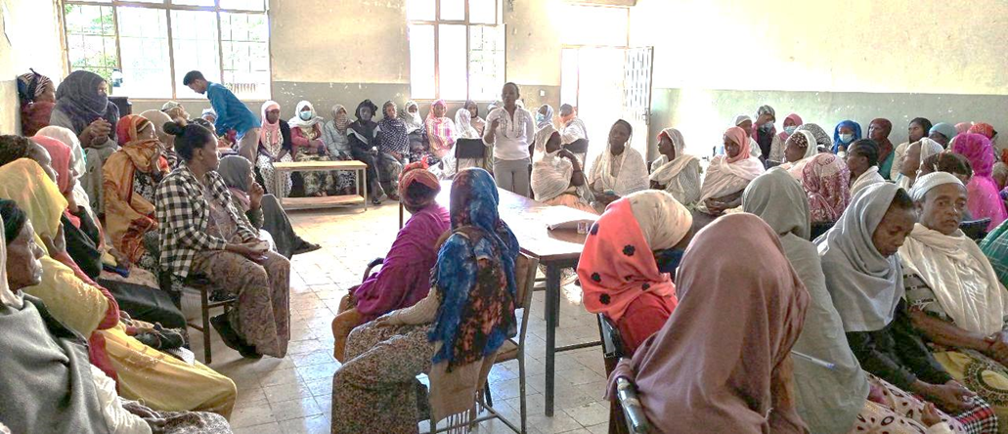
Group dialogue sessions at Butajira town
Intermediate Result 1.3: Mitigation of OVC programming: Comprehensive OVC & Primary prevention.
- Offered and enrolled new 1,421 OVC clients into the program’s care and support service delivery at the implementation towns including OVC program expansion sites Bonga and Tepi.

- Provided home-to-home need-based care and support services for 5,038 OVC and 1,097 care givers as per the identified needs and developed care plan. We mobilized CWs to provide services to enrolled clients in the OVC comprehensive Program. The services that are based on their care plan are categorized by food and/or other services, shelter and care, education or vocational training, protection, and legal aid services, as well as economic strengthening services, and the eligible adults and children provided services with psychological, social, or spiritual support services.

- Provided educational counseling on importance of education, attendance, performance to 3,100 school age OVC and their caregivers through home visits by SSWs and CWs.

- Provided various types of assets to destitute households based on their business plans to 41 households at Butajira, 35 at Hossana, 72 households at Mizan, and 9 households each at Bonga and Tepi towns. For this round of assets provision Teff, Sheep, Maize, and Wheat/barley were supplied.
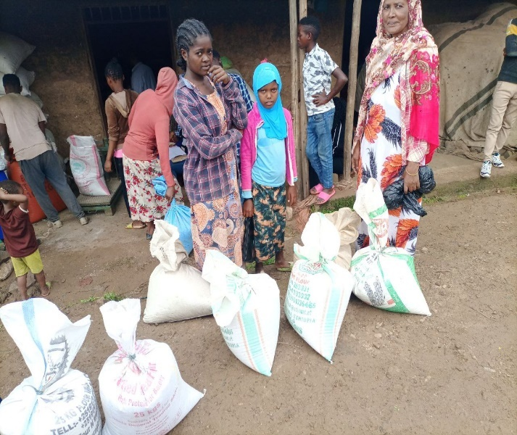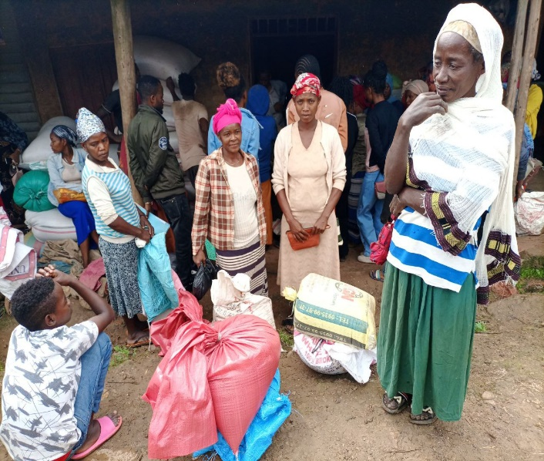
Transfer of assets at Mizan town
- Established 16 VSLA (Village Savings and Loans Associations) with 320 members which were provided with VSLA savings box and trained in savings, loan mgt, record keeping, development of by-laws and other procedures for effective group mgt.

- Cascaded the IMPOWER-IMSAFER program training for 1,171 adolescent girls at Mizan, Butajira and Hosanna towns through trained and certified training instructors.
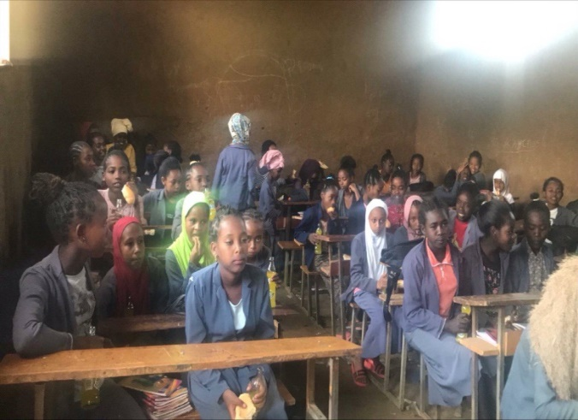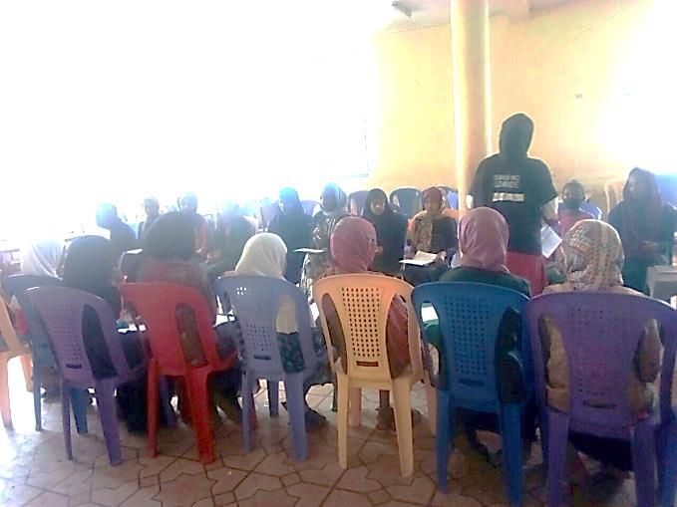
IMPOWER-IMSAFER trainings at Mizan (on the left) and Butajira (on the right)
- Cascaded the Sinovuyo teens program training for 161 10-14-year-old boys and girls and their care givers at the Mizan, Butajira and Hosanna towns through trained facilitators.
- Cascaded the CBIM training to 469 9-14-year-old boys in school through their trained and certified sport coaches at Butajira, Hosanna and Mizan.
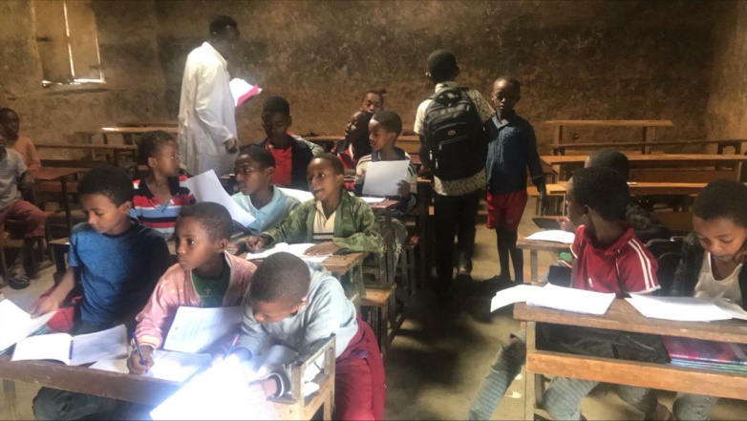
CBIM training during after school hours at Mizan
Result 2: Strengthened utilization of data to monitor service delivery and conduct quality improvement of program services.
- Conducted performance review meetings with government, community representatives, health facility representatives of project partners at each implementation towns to discuss on quantitative and qualitative performance of the project, challenges with partnership, integration and collaboration and provide way forward.
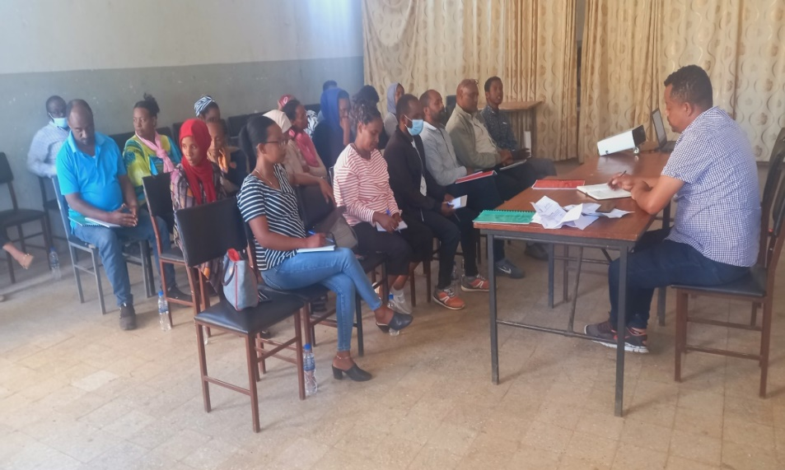
Partial view of review meeting at Butajira town

- To resolve data quality issues especially consistency between source documents and reports, all towns implemented Quarterly based Routine data quality assessment (RDQA) on the project indicators.

- Developed and implemented Quality improvement projects across all towns; The sample run chart below shows Hosanna town’s project to improve OVC service source documentation at kebele level.

Major Challenges and Actions taken
Major challenges
- Delayed budget release
- HIV testing Line lists received were out of our catchment areas and some clients relocated.
- Inadequate contact elicitation.
- Performance gaps that required comprehensive improvement.
- Some Lost to follow-up clients address was wrongly filled and had no phone numbers.
- Unavailability of HIV test kits, especially Self-test kits
- Absence of vehicle for Butajira coordination office which makes it difficult to provide timely support to Hosanna town.
Actions taken
- Conducted performance review discussions with association and town health office to resolve the issues and reach consensus.
- Implemented volunteer motivation mechanisms and reviewed Weekly performance review/evaluation of community service providers.
- Although insufficient, the sites borrowed self-test kits from nearby HFs.
- Improved community HIV care and treatment transportation and travel allocation to alleviate the problem until Mary Joy/USAID responds to our request.

