,l
Bi-annual Performance Report (January 1, 2022 – September 30, 2022)

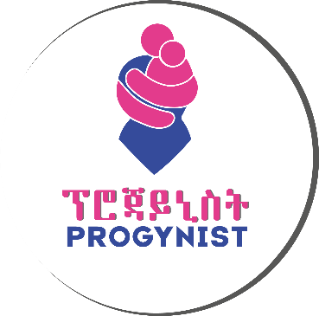

Program I

USAID/ETHIOPIA Family-Focused HIV prevention, care and treatment services

Executive Summary
Progynist has made excellent strides towards combatting gender-based violence with sexual violence prevention interventions and several awareness campaigns. It continually made efforts to strengthen the capacity, collaboration, and commitment of others to increase gender equality. It made primary duty bearers at the forefront of gender and gender-based violence interventions.
Continuing throughout the year 2022, Progynist implemented community-based HIV services program through partnerships with local authorities and by mobilizing community resources to improve the lives of HIV affected orphan and vulnerable children and their adult caregivers. Progynist has also been working towards the enhancement of the response of communities to violations of rights of women and girls by especially addressing gender-based violence.
Acronyms
AGYW Adolescent Girls and Young Women
ART Anti-Retroviral Treatment
ARV Anti-Retroviral Viral
BoWCA Bureau of Women and Children Affairs
CAG Community ART Refill Group
CBO Community Based Organization
CC Community Committee
CCC Community Care Coalition
CEF Community Engagement Facilitator
CG Care Giver
CRP Community Resource Person
CW Case Worker
DSD Direct Service Delivery
DSDM Differentiated Service Delivery Model
FBO Faith Based Organization
FP: Family Planning
FSW Female Sexual Worker
GBV Gender Based Violence
HAPCO HIV/AIDS Prevention and Control Office
HCT HIV Counseling and Testing
HF Health Facility
HIVST HIV Self-Test
HTC HIV Testing Counseling
HTS HIV Testing Services
ICT Index Case Testing
KP Key Population
OVC: Orphan and Vulnerable Children
PEPFAR Presidents Emergency Plan for AIDS Relief
PLHIV People Living With HIV
SNNPR: Southern Nation Nationalities People Region
SNU Sub National Unit
SOP Standard Operational Procedure
SSW Social Service Workers
TOT Training of Trainers
TX_CURR Currently Receiving Antiretroviral Therapy
VL Viral Load
VLS Viral Load Suppression
WCYAs Women, Children and Youth Affairs
WROs Women Rights Organizations
Bi-annual performance of the program
Progynist operates in Addis Ababa, Guraghe zone in Butajira, Hadiya zone in Hosaena and Bench-sheko zone in Mizan Aman of the newly formed South-west region. It has successfully expanded into the Sheka zone, Tepi town to implement the Family-focused HIV prevention, care and treatment services program.
Project Name | Period of Activity | Annual Budget (ETB) | Program Status | Project site/s
USAID/ETHIOPIA Family-Focused HIV prevention, care and treatment services | January 1, 2022 – September 30, 2022 | 15,033,347.50 | Ongoing | - Butajira  - Hosanna  - MizanAman  - Tepi

Program Description for year II
The project is funded by United States Agency for International Development (USAID)/Ethiopia. Progynist signed an agreement with the donor to implement the program for three years with a total budget of 15,033,347.50 birr.
The project is designed to achieve two broad-spectrum results i.e., increased access & demand to family-focused HIV services that reduce HIV incidence in the community and Strengthened utilization of data to monitor service delivery and conduct quality improvement of program services. Progynist, as a local implementing partner (LIP), will implement Family-Focused HIV Prevention, Care and Treatment Services in SNNPR in Guraghe zone at Butajira, Hadiya zone at Hosaena, Bench Sheko zone at MizanAman and Sheka zone at Tepi towns to address the needs of 7589 orphan and vulnerable children of 1295 KPs and PPs adult care givers. Progynist will reach all target project geographic areas, target families and communities with intended services.
  - Goal, objectives
- The overall goal of this project is by 2023, to reinforce and revolutionize the multi-sectors and multi-stakeholder responses of HIV epidemic control at Butajira& Hosanna at SNNPR and Mizan & Tepi at South-west Region.
  - General Objective:
- To improve the lives of 7987 orphan and vulnerable children by increasing access & demand to Family-focused HIV services that reduce HIV incidence in the community.
  - Specific objectives:
- To contribute to the attainment of HIV epidemic control within the target SNUs by 2023.
- To strengthen utilization of data of the 9279 beneficiaries to monitor service delivery while applying continuous quality improvement of program services every year until 2023.

Implementation Strategies
    - Operation Triple Zero: To achieve this purpose, the project will ensure that the targeted SNUs, Woreda Health bureaus and Health Facilities, community structures, CCC, FBOs CBOs and stakeholders have the capacity to facilitate high quality HIV/AIDS related services for HIV impacted OVC tailored to addressing TRIPLE ZERO approach namely: Zero missed appointments, zero missed medications, zero viral load, zero infections 9-14 to contribute to national 95/95/95 goal. The OTZ (Operation Triple Zero) interventions will be used to reach all children/adolescents with HIV. Progynist will facilitate PLHIV support group /OTZ club/ at Butajira, Hosaena and Mizan Aman.
    - Accelerating community-based ART: Progynist will enhance acceleration of community-based ART to full implementation in all project areas and significantly reduce patient loads at health facilities, especially during COVID-19pandemic conditions. To do this, we will advocate and lobby the health sectors in the targeted SNUs on strengthening and expanding the implementation of the 6 months multi-month dispensing (MMD) and introduce health worker managed Community ART refill Groups (CAG) and promote fast track pharmacy refill at the three targeted SNUs.
    - Realigning OVC program to HIV treatment program: OVC/C&T will use case management standard procedures to assess needs and deliver family focused integrated services for targeted OVC sub-populations including HIV+ children, adolescents and children of HIV+ mothers. The project will prioritize fostering facility and community-based Index Case testing of KPs and PPs adults and their biological children by tracking them in the community and providing professional assisted self-testing. Currently, Progynist has MOUs with health facilities, CC/CCC in targeted SNUs that will be utilized and updated in the context of this project. There are several community cadres the partners are already working with including SSWs, Case Workers, health facility professionals and health extension workers.

    - Focused HIV testing and linkage for newly diagnosed cases in the community: Approaches include user friendly services for adolescents, facilitating separate space and scheduling for clients with high viral load, establishment and facilitation of Facility-Community collaboration for case identification, adherence support and tracing of lost clients. Health facilities and providers will be capacitated to address the demands and needs of those who might be displaced or self-transferred.
    - Delivering differentiated service package for pediatric, adolescent and adult ART clients to improve retention, adherence and viral load suppression: HIV/ART literacy education to caregivers on HIV/ART, Disclosure support for caregivers so children/adolescents with HIV infection are disclosed of their HIV status, HIV/ART literacy education to adolescents with HIV through peer-led group support.
    - As innovative approach Progynist deploys U = U initiative which includes one to-one peer support for newly initiated patients and those with high viral load. The strategies include reinforcing interface between community and facility-based actors; improving documentation of patient demographics; engaging FBOs as program advocates and ensuring messaging that is consistent and aligned with evidence-based approaches for HIV case identification, treatment of HIV and co-morbidities, and at the same time respecting and adhering to social and religious values among the community. Additional strategies include ongoing bring back-to-treatment periodic campaigns. The following tools will be used to ensure proper adherence assessment and support is provided for each infected child/adolescent: Appointment calendar to track ART and viral load testing dates and send reminders ahead of time, Scripted adherence counseling guide to provide proper support and identify adherence barriers ahead of time before a problem arises, Adherence barrier analysis and support for clients who are LTFU, have missed appointment, missed dose, or high viral load. For clients with high viral load, enhanced adherence counseling and support will be provided.
    - Primary prevention for HIV and violence among 9-14-year-old: We will use the PEPFAR approved curriculum of IMpower and Sinovuyo Teens. We will work with the curriculum developers to complete the ongoing TOTs to build capacity of our trainers and scale up reach to adolescents and their families and communities with the curriculum interventions.
    - Supporting risk and needs assessment of beneficiaries encountered by the program or served by collaborating agencies to mitigate risk of HIV acquisition, ART retention and adherence barriers to improve viral load suppression. A risk assessment tool will be systematically applied to all identified at risk children, youth and adults with unknown HIV status in all the target SNUs to determine which of them need to be tested.
    - Quality improvement approach: Two models will be used to address gaps in quality in ICT and viral suppression cascade. Training will be provided to project staff based on FHI360’s quality improvement model using Plan Do Study Act (PDSA) cycle.
    - Cross cutting themes: Progynist will work to addressing HIV and gender equitable HIV prevention, care, treatment and support to promote positive gender norms; Gender-based violence prevention and care services for beneficiaries identified by the program including post-GBV care; and increase gender equitable access to income and productive resources, including education and health care.
    - HIV and COVID-19: The project implementation will give due attention to reduce the transmission of COVID-19 which might be the additional burden of HIV through protecting front line health workers and technical staff of the project using USAID guide lines and principles that will enable us to protect the gains of thus far efforts on HIV responses.

Program Performance

Result 1: Increased access & demand to family-focused HIV services that reduce HIV incidence in the community

Intermediate Result 1.1: HIV testing and counselling in the targeted SNUs increased.
- During the 9-months period, Progynist provided HIV testing and counseling services to a total of 2182 clients, 1201 (55%) females and 981 (45%) male clients/contacts of HIV positives at Mizan, Tepi, Butajira and Hosanna sites.
- Progynist identified a total of 170 (103 female and 67 male) HIV positives, 34 at Butajira, 34 at Hossana, 66 at Mizan and 36 at Tepi sites through index case testing strategy. Most of the identified cases were spousal/non-spousal contacts of HIV positive index cases. All 102 (100%) of them were linked to health facilities for counseling and initiation of anti-retroviral treatment.
- Progynist provided Unassisted/Assisted self-testing options to clients who preferred that option instead the traditional conventional testing by the provider. During the year 77 kits were provided at all sites where 56 (73%) were for female clients and the rest were male. Through this approach, 12 HIV positives were reported, which were confirmed by our service providers.
- Contact elicitation training was provided for two days to 40 ART clinic staffs of targeted health facilities, case managers and CRPs ART focal persons, adherence supporters, case managers were mainly included. After training, the participants had improved their understanding about HIV index contact elicitation.
- Provided comprehensive community-based case management service refresher training for 36 community resource persons and case managers for 3 days at all implementation towns
- Purchased and provided HTS commodities such as 43 safety boxes, 15 boxes of examination gloves, 283 cotton packs and 140 bottles of alcohols. HIV testing kits, condoms and COVID-19 prevention hand washing equipment were provided by the prime partner Mary joy Ethiopia in collaboration with Project Hope, PSI and PFSA at all sites.
Intermediate Result 1.2: HIV retention and adherence services improved
- Quality improvement teams established at all implementation towns to implement QI activities that are designed program performance. QI teams are composed of focal personnel from Health facilities, woreda/town level health departments, Progynist’s community engagement facilitators, and other relevant government signatory offices.
- Quarterly consultative meetings with potential service providers, FBOs, CCCs, and CBOs to establish smooth referral linkage for PLHIVs was conducted at all implementation towns.
- Provided need-based community care and support services to 790 (84%) clients in the community level with services that include routine adherence counseling and continuity of treatment, psychosocial services, screening for mental health, STI, and TB and services for community-based NAC.
- Cervical ca screening and treatment demand creation was provided to 396 WLHIVs through 8 CEFs and 36 CRPs in collaboration with PLHIV associations to enhance accurate sensitization to cervical cancer and the necessity of screening and treatment, and reduce stigma among WLHIVs.
- Progynist provided cervical cancer (CxCa) screening and referral services to 36 PLHIVs. Out of the 36 referred cases, 5 of them tested positive for the cancer test. The rest were negative.
- The implementation towns provided GBV screening, referral and support for 51 (80%) clients (Butajira 13, Hosana 11, Mizan 16 and Tepi 11) to access local clinical (e.g., STI, FP, MCH, etc.) and non-clinical services (e.g., longer-term psychosocial support, shelter services, economic empowerment activities, etc.) that will assist with continued recovery.
Intermediate Result 1.3: Mitigation of OVC programming: Comprehensive OVC & Primary prevention.
- Aimed at successful and quality service delivery, Progynist facilitated Coordination of care refresher training for 15 selected Kebele CCC members, 235 volunteer case workers and 11 social service workers for an improved implementation of OVC service delivery at all implementation towns.
- Provided home-to-home care and support services for 4821 OVC and their 1343 care givers as per the identified needs and developed care plan. We mobilized CWs to provide services to enrolled clients in the OVC comprehensive Program.
- During the reporting period, Case Workers provided comprehensive services for CGs and OVCs, who are in comprehensive services, during home-to-home visits.
  - Provided disclosure support counseling to 107 OVCs and their 332 caregivers;
  - Provided referral to civil registration services for 270 OVC,
  - Provision of hygiene counseling and WASH messaging for 1425 OVCs,
  - Educational counseling on importance of education, attendance, performance was provided to 1701 OVCs and their caregivers through home visits by SSWs and CWs.
- Business Development support (BDS) and Selection, Planning and Management (SPM) training was provided to 123 care givers of OVCs.
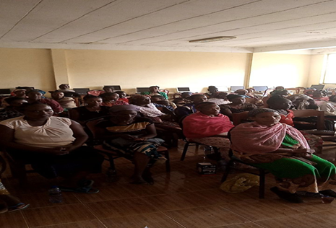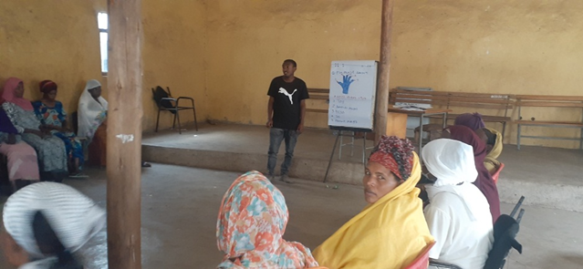
Business Development Skills training at Mizan (on the right) and Butajira (on the left), April 2022
- Financial capability training which focuses on combination of attitude, knowledge, skills, and self-efficiency needed to make and exercise money management decisions that best fit the circumstances of one’s life was provided to 123 caregivers of OVCs.
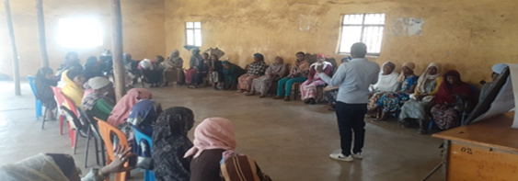
Financial Capability training at Butajira town, April 2022
- After conducting needs and market assessments at all target towns, Progynist facilitated the purchased and delivered assets to 275 households located at Butajira, Hosanna and Mizan, households who are classified as destitute based on their uniquely identified needs to achieve economic productivity.

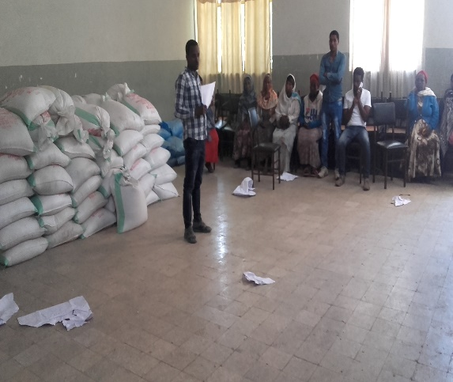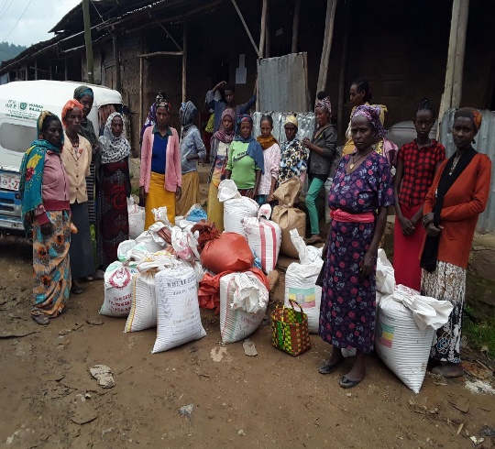
Asset transfer to destitute Households at Butajira (on the left) and at Mizan (on the right), March 2022
- Established Village Savings and Loans (VSLA) Groups and provide 3 days VSLA training 41 VSLA groups National ES guideline.

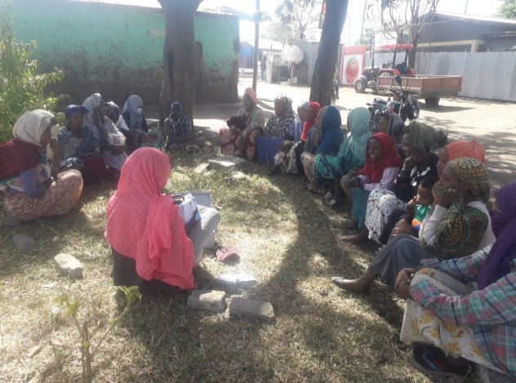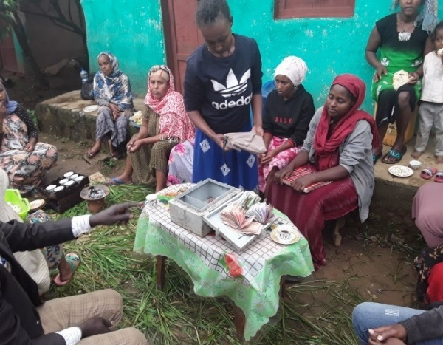
VSLA groups at Butajira (on the left) and at Mizan (on the right), February 2022
- Provided IMPOWER-IMSAFER curriculum-based violence prevention training to 1088 girls 9-14 years for a total12 hours which is 3 hours per session.
- 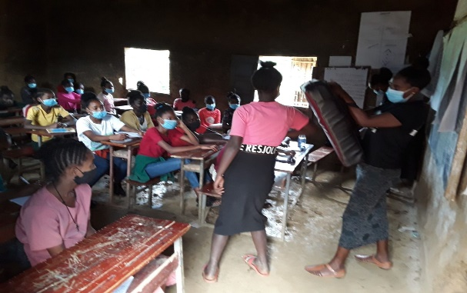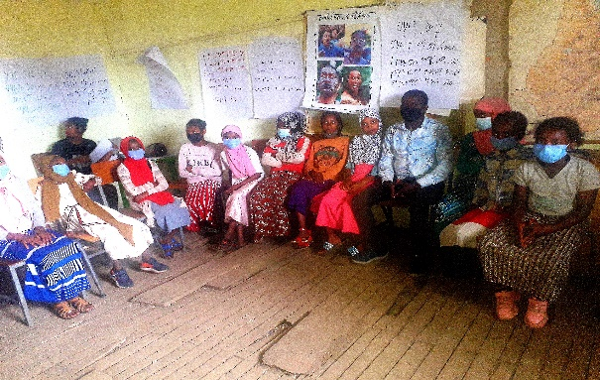
Impower-IMsafer training at Hosanna (on the left) and at Mizan (on the right), March 2022
- Provided Sinovuyo (parenting training) to 494 OVCs and their care givers at Butajira, Hosanna and Mizan for a total of 3-days.
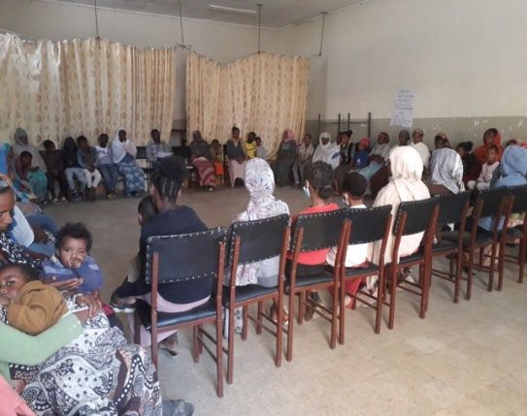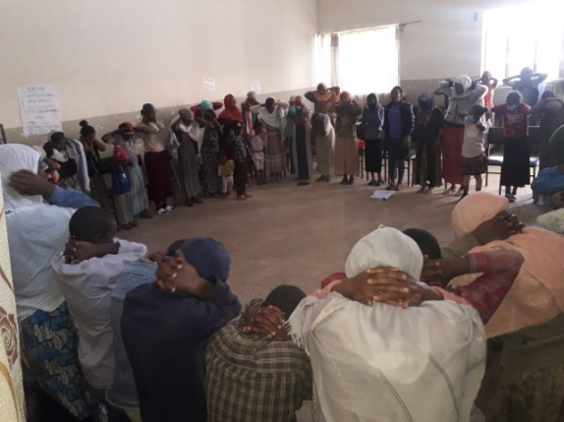
Sinovuyo training at Butajira (on the left) and at Hosanna (on the right), February-March 2022

- Provided coaching boys into men (CBIM) training to 9–14-year-old boys at school venues. This training is provided to create awareness for all boys in the school and to let them know and practice gender equality It helps them to respect adolescent girls and safeguard them from any form of sexual violence.
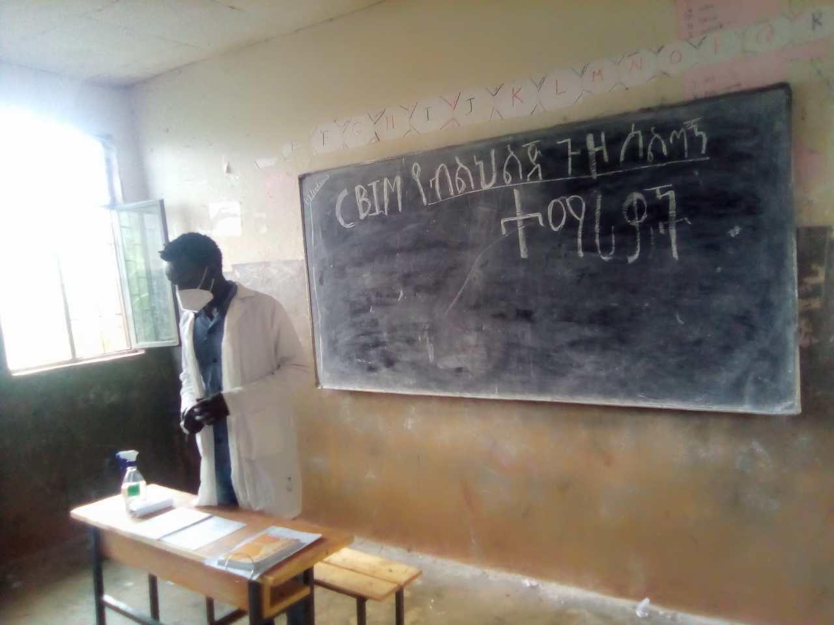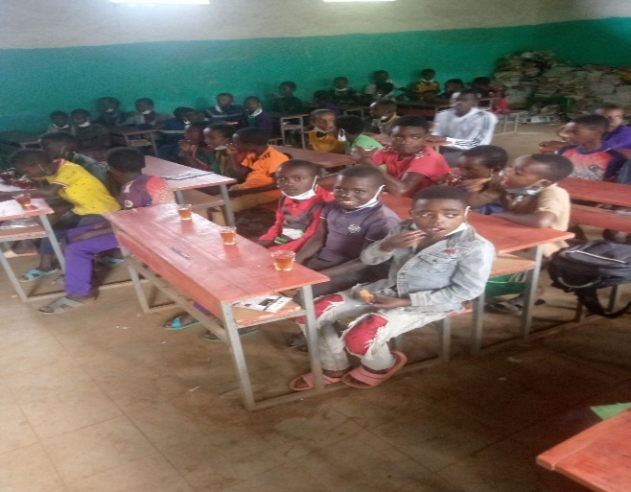
CBIM training to 9-14-year-olds at school venues in Mizan town, March 2022
- Conducted performance review meeting with all project partners at zone and woreda level at the implementation towns. Representatives of WCYA, BoLSA, BOH, BOFED, BOE, and community groups, and delegates of Health facilities participated. The purpose of the meetings was to review quarterly based performance at each implementation which evaluates plan vs achievement on Program indicators.
- To resolve data quality issues especially consistency between source documents and reports, all towns implemented Quarterly based Routine data quality assessment (RDQA) on the project indicators.
Program II

Civil Society Support Program Phase II (CSSP2) - Propelling Commitment towards Gender Transformation

Project Name | Period of Activity | Annual Budget (ETB) | Program Status | Project site/s
Civil Society Support Program Phase II (CSSP2) - Propelling Commitment towards Gender Transformation | January 1, 2022- September 30, 2022 | 2,026,034.05 | Phases out March 2023 | - Addis Ababa  - Butajira

Executive Summary
Progynist CSO wishes to deepen its achievements around women’s political participation and decision making and GBV issue, specifically taking into a snap survey was conducted in May 2020 to understand the level of the local context of women’s political participation, GBV, and other challenges they have been facing. The survey also touched upon the degree of implementation of women related existing laws and engagement of communities in national advocacy for revision of policy instruments to ensure the protection of the rights of women and girls. The extended project is named as propelling the commitment to gender transformation. The intervention areas of the project are Addis Ababa (yeka sub city of woreda 08, 09 and 12) and SNNPR in Guraghe zone. (Butajira, Meskan and East Meskan).
- Program Description
The project was designed to deepen its achievements from the previous CSSP2 and based on the Snap Survey had conducted in May 2020. The Snap survey highlighted on:
- Understanding the level of the local context of women’s political participation, GBV, and other challenges they are facing
- Measuring the degree of implementation of existing laws and engagement in the national advocacy for revision of policy instruments to ensure the protection of the rights of women and girls.

- Objective
The overall goal of this project is empowered women and their institutions capable of ensuring the rights of women, girls with disability, HIV/AIDS, and other minorities.
- Implementation Strategies
Gender Transformation Approach: The proposed project intends to adopt Gender Transformation Approach to create opportunities for individuals to actively challenge gender norms, attitudes and social systems and propel the commitment of institutions and community members to combat underlying causes of gender disparity.
Engagement: The intended project focuses on engaging men and boys, enhancing state citizen engagement through continuous dialogue and consultation among community members and institutions such as CSOs, WROs, women and girls of all categories, religious institution, traditional structures and pertinent local Government bodies. To facilitate and sustain engagement of community members, the proposed project creates platforms, build capacities and facilitates enabling environment.
Women Empowerment: The intended project recognizes that lack of women's empowerment is a critical aspect of gender inequality. Barriers to women empowerment, which exists in many forms, thus, make women and girls, especially women with disability and living with HIV/AIDS, vulnerable to deprivations of services as well as denial of entitlements. The different forums are specially designed to assist women to challenge existing social norms and influence existing policies and lobby for revision of obsolete laws.
Linkage and Collaborative Relationships Among Stakeholders: The project will establish and strengthen collaborative relationship with Women, Children and Youth Affairs offices and other concerned government offices, women associations and groups including WROs, public and private facilities and organizations in the intervention areas to facilitate their engagement in addressing the problems faced by women and girls in the intervention area.
Advocacy/Campaigns: Advocacy as a strategy is integrated in the project in order to educate the public as a whole through undertaking advocacy initiatives in cooperation with WROs, WCAO, female and male youth associations and other community members.
- Staffing
Progynist deployed the following personnel in Addis Ababa and SNNPR, Guraghe zone
- 3 key staff (2 women and 1 man)
- 1 community facilitators (1 women, 1 man)
- Program Performance
    - Training was provided for 6 facilitators on social accountability, facilitating FGD, and citizen engagement. The training participants were from Addis Ababa Yeka sub-city of 3 Woredas 8, 9, and 12, (3 women) and 3 participants from SNNPR Butajira, Meskan, and East Meskan woreda of which 2 were women and 1 was Male. The purpose of the TOT was to enhance the capacity of the facilitators in organizing and facilitating FGD and citizen engagement. Participants comprised of the Peace and security office, WCAO, PLWHIV, disability association representatives, schools, courts, GBV survivors, political parties, women’s associations, religious leaders, and health office.

    - This training equipped the facilitators with the required skills when organizing and facilitating social accountability, and citizen engagement as well as facilitation skills when organizing FGD in order to instil accountability among the community and government. Consequently, this develops a sense of transparency in the work they are responsible for. It sets a check and balance system or a controlling mechanism that can ensure services are delivered appropriately.

    - Discussion was organized in the three Woredas (8,9 & 12) of Addis Ababa and Butajira town, Meskan and East Meskan of SNNPR on Social Accountability that takes into account a service provider and service recipients. The facilitators' training was held on facilitating FGD and citizen engagement, and social accountability. A total of 240 participants have participated in both project sites of which 133 female and 107 were male. They used scorecards in order to improve and take responsibility for the services that they provide and recipients by the services they receive. This is done by sorting out the problems, their sequence of importance, and causes for that particular issue.

    - The domestic violence act demonstrates the legal framework designed for the protection of women against physical, sexual, psychological, and economic violence issues and harmful traditional practices. Domestic violence and the legal issue to apply in practice were explained thoroughly. The issue raised during the training was that most domestic violence issues were perpetrated by families and male relatives.

    - The training was conducted for only women leaders in order to enhance their knowledge on the causes of domestic violence, on how to prevent it before it takes place measures to be taken after the violence happened and the role of legal institutions were clearly defined. The women leaders from various government sectors shared their experiences on the legal side of domestic violence and created linkage to lobby for the promulgation of the Domestic Violence Act.
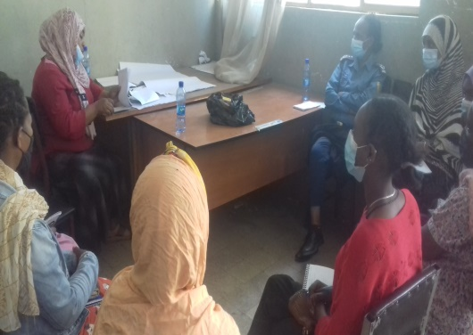
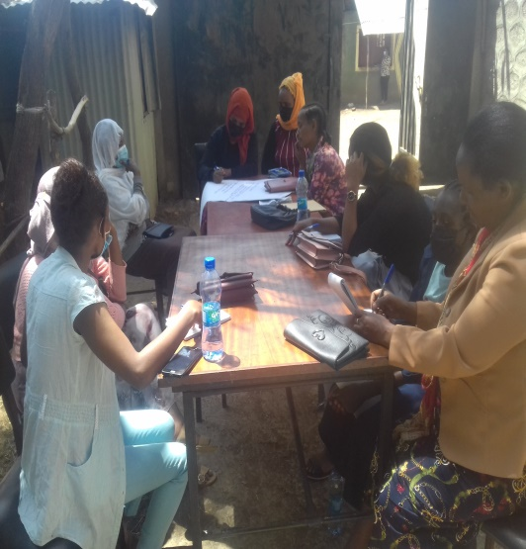

Group Discussion on Domestic Violence Acts (Butajira)
- In partnership with WCAO, organized a workshop with participants from school communities, parents, and adolescent girls in attendance, with a focus on gender roles and the legal issue to apply in practice. The gender roles and stereotypes include; gender roles attributed by traditional beliefs in the communities, the natural difference between male and female, and the gaps in traditional classification of the roles of male and female. Participants of the training were from elementary and high school students of grade 8,9,10, 11 and 12, parents, teachers, from WCAO, from mini media and school clubs’ representatives.
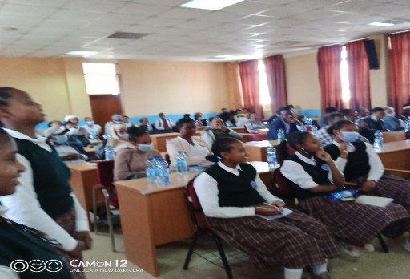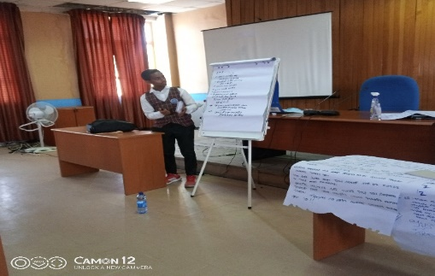
Training on Gender roles, Addis Ababa
- Gender Justice Committees were established across implementation sites, with members from WCAO, peace and security office, health office, education bureau, students, disability association members, women’s association, social affairs, social court, edir, and police were established. The Gender Justice Committee was drawn from Yeka sub-city Woreda 8,9 and 12 and SNNPR Butajira, Meskan and East Meskan Woredas. The committees are 100 of which 74 are female 26 are male.

- Gender justice committees developed action plans to address the community problems, specifically gender-based violence acts by conducting a progress review meeting every two weeks in their respective Woredas which would help them share their individual experiences. The cases the committees collect will be discussed during the meeting and they will assess each case and identify potential rights violations and provide solutions to those that require it.

- One-day interface meeting was organized and facilitated to Service providers and service recipients to discuss the issues raised at the FGDs and arrange for MOU signature. A total of 100 participants attended the discussion, of which 74 are women and 26 are men. Participants came from Addis Ababa, Yeka sub-city (8, 9, & 12), and Butajira project site from the three woredas of service providers and service providers.

- The participants representing the service providers and service recipients discussed the issues raised at the FGDs and arrange for MOU signature, and assist in establishing a Gender Justice Committee composed of 100 persons, 15-20 persons at each location to sustainably address gender gaps. It shall have an executive committee composed of 7 members. The committees were composed of different offices which were selected from the FGD groups.
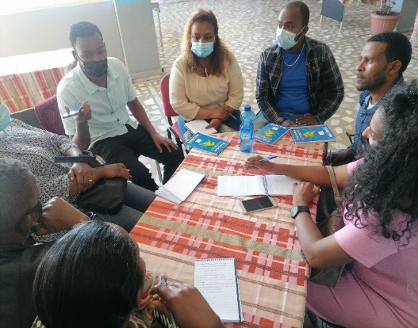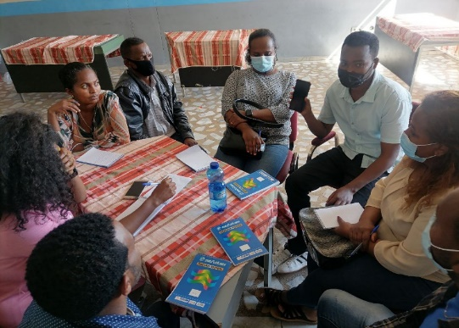
Focus Group Discussions (AA)

- During the six-months implementation period, organized various review meetings to engage its key stakeholders involved in the project. The aim of these meetings was to actively involve each stakeholder at every step of the project, to make them own the outcome of the project and to ensure sustainability.

- A review meeting was organized involving stakeholders from woreda level WCAO, PSO, Edir, Health office, Women association, Education bureau, Association of PLWD, Social courts, representatives from Political parties and FBOs at all implementation sites. A total of 42 representatives from Addis Ababa and 48 representatives from Butajira participated in the meeting. The accomplishments over the previous months were presented to the invited guests who reflected on what went well, pointing out the strengths and the weaknesses/challenges.

  - During the first quarter review meeting with the gender justice committees, the progress of the committee’s activities has been reviewed and discussed with each project area. The participants of the committees acquired knowledge and experience by the raised basic issues related to MOU signed previously. The experience raised and shared the need for an action plan and accomplishing sets of activities listed in the MOU by taking responsibility. The participants also raised the need for a regular meeting and hold minutes to perform activities listed on the MOU.

  - During the meeting, the participants also discussed peace and the need for peace for women and children to live peacefully in their local environments. In these discussions, the conflict resolution performed between East Meskan woreda and Mareko woreda brought the most significant advantage for the people living in both woredas. In general, the committees suggested and commented on the advantage of peace and every individual’s responsibility to ensure peace in the project areas including in the country. Majority of the participants appreciate CSSP2 on its effort of minimizing GBV issues by collaborated and integrated works with stakeholders. They also gave comment on the decrease of the number of GBV issues and increased number of women participants on politics. Most of the participants suggested that programmatic actions should focus on schools because of rising incidents around schools and the perpetrators as well as victims being the students.

  - During the second quarter review meeting the performance of the last six months was presented to the committees and discussed on the performed activities and their performance. The participants admired the mutual results of the achievements of more than 90%.

  - The meeting also provided a platform to review and reflect on the progress of the committee’s activities in project implementation area. The committees presented the cases that they have handled in the previous 6 months with their team and the steps they took to reach an equitable decision for the victims/survivors (women, girls, disabled people, and other minority groups. The committees met every two weeks after the 1st quarter meeting and report the cases that they have found in their respective woredas also the solution will be contributed for the victim of GBV as the responsibility of the Gender Justice Committee is to urgently respond GBV acts to women, girls, and other minorities.

  - The meeting has enhanced the capacity of Gender Justice Committee (stakeholders) on finding cases of GBV and by following, steps that leads to the solution by collaborating with each department and this committee helps most of the WCAO department to easily negotiate wife and husband cases as they are cooperated with court and police office.

- The committee members forwarded the identified gaps to fill in the coming meeting related to taking responsibility to perform MOU contents signed before. They also forwarded that even if there are overlapping of tasks, they should take time to perform GBV issues listed in the MOU.
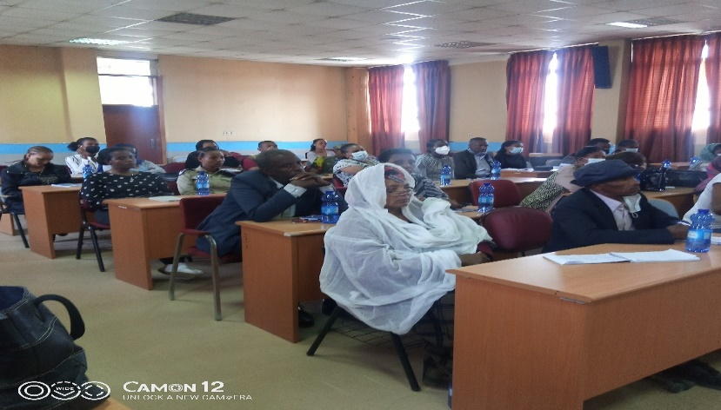
Gender Justice Committee Review Meeting (AA)
- 42 members have selected from both project sites among them 25 members were female and 17 members were male (Addis Ababa 23/Butajira 19)
- Conducted GJC Executive committee monthly meeting: The executive committee monitors the GBV cases occurring in each Woreda on a daily basis, and ensure immediate response. The executive committee holds monthly meetings and discuss on issues raised during the meeting and submits monthly reports.
- Updated community-based service provider directory through mapping.
- 50 women were selected both in Addis Ababa Yeka sub-city and SNNPR who are GBV victims to provide support. The victims faced physical, psychological, economical, and sexual violence. Each Woreda WCAO took the responsibility for selecting these victims by considering and giving priority to the women whose cases are urgent by having a thorough discussion with the executive gender justice committees.
- A one-day forum was conducted for 60 girl potential leaders whose work will be monitored by Progynist & Gender Justice Committee. This was meant to bring girl aspirants to public stage by exercising public speech and debates in order to prepare them for the promotion of their causes and pursue their ambition as future leaders. A total of 79 participants were attended in both project areas. (Addis Ababa (Two times) = 50 and Butajira = 29)
- Bi-annual review meeting with 100 members of GJC many of who are representatives of community-based service providers within the target Woredas. The meeting was held in both project areas with the members of GJC of service providers and service recipients on addressing the urgent cases that occur in their communities. There were 63 female participants and 27 male participants with a total of 90 (Addis Ababa = 42 and Butajira = 48) persons participated in GJC meeting. The participants were from Edir, WCAO, Peace and Security Office, Religious Institutions, Education Bureau, Health Bureau, Women’s Associations, and PWDs.
- Training for one day on Safe guarding policy to 90 WCA, Social affairs, offices school communities, the Police, Social court, at 60-40% female/male ratio; A total of 57 participants attended the training in both project areas (Addis Ababa: 29, and Butajira: 28). The training participants were from Women and Social Affairs Office, Peace and Security Office, Disability Association, and Women’s Association with 37 female and 20 male participants. Out of the total participants 3 participants were drawn from PWD’s.
- One-day Review meeting with 100 representatives of stakeholders (60-40% female to male). A total of 43 participants were presented. The participants were 28 female participants and 15 male participants. The stakeholders are drawn from Women and Social Affairs Office, Peace and Security Office, Religious Institutions, Education Bureau, and Women’s Associations.

Program III

This Project is entitled, Leveraging Women’s Potential for Maintaining & Sustaining Peace& the impact of COVID-19 on the social and economic safety of women and children

Project Name | Period of Activity | Annual Budget (ETB) | Program Status | Project site/s
PIE Leveraging Women’s Potential for Maintaining & Sustaining Peace | January 1, 2022 – September 30, 2022 | 2,047,480.06 | Phases out March 2023 | - Addis Ababa  - Butajira
- Program Description
This project is entitled, leveraging women’s potential for maintaining & sustaining peace & the impact of COVID-19 on the social and economic safety of women and children. The project is named as Leveraging Women’s Potential for Maintaining & Sustaining Peace. The intervention areas of the project are Addis Ababa (Nifas Silk Lafto Sub City Woreda 8 & 10) and SNNP (Butajira, Meskan and East Meskan).
- Objectives

- To build the capacities of 80 women/girls, 40 from religious institutions, traditional structures and government offices, 40 male youth, a total of 160 with due attention to the disabled persons, encouraging PLWHIV) to become Peace Promoters out of which 20 persons would be a Steering Committee member (10 from each of the 2 woredas)
- To bring visibility to women’s issues and concerns on gender equality, peace and security so that their voices are heard.
- To popularize and advocate for the effective implementation of UNSCR 1325 Resolution, an international law that call for women’s inclusion in peace processes and decision making.
- To build the capacity of Progynist’s governance structure, head office and field staff on the important role of women in peace building, protection from GBV and how they could practically share the vision of Gender equality in Ethiopia.
- Build the organizational capacity of Progynist by way of training its essential staff, putting the required policies and guidelines in place, publish its experiences on gender equality and also ensure that it has a dependable logistical equipment.

- Implementation Strategies

- Gender Transformative Approach: the shared control of resources and decision-making and women’s empowerment are central to the project, it will create opportunities for individuals to actively challenge gender norms, attitudes and social systems that are underlying causes of gender inequality.
- Women Empowerment: recognizes that lack of women's empowerment is a critical aspect of gender inequality. Barriers to women empowerment, which exists in many forms, thus, make women and girls vulnerable to deprivations of services as well as denial of entitlements.
- Capacity Building: capacity building support will be provided to enhance the institutional and technical capacities of WROs or other initiatives involved in the promotion of the rights of women and girls.

- Linkage and Collaborative Relationships Among Stakeholders: The project will establish and strengthen collaborative relationship with Women, Children and Youth Affairs offices and other concerned government offices, women associations and groups including WROs, public and private facilities and organizations in the intervention areas to facilitate their engagement in addressing the problems faced by women and girls in the intervention area.
- Staffing
Progynist deployed the following personnel in Addis Ababa and SNNPR, Guraghe zone
- 3 key staff (2 women and 1 man)
- 3 community facilitators (2 women, 1 man)

- Program Performance

- This training was given to deepen the importance of the UNSCR 1325 resolution as it was given to people from women and children affairs office, peace and security office, social affairs office, disability associations, women associations, youth volunteers office to cascade the idea among the community.

- The training was provided with issues of importance of peace, human right implementation, the UNSCR resolution on peace and women proclamations and the role of women in peace building process.

- Progynist is a woman focused organization with a vision that woman has to participate fairly politically, economically, and socially in Ethiopia. As per the new CSO proclamation, our vision and mission statements were revised as to the need and objectives of the organization.

- The booklet was prepared in order to promote and recognize our organization with other local and international civil society organizations and the community at large. 200 booklets were published.

- The brochure was prepared to advocate women’s rights. The content includes international and national laws and proclamations that support women’s rights. In addition to international and national laws, the international women’s days are listed (march 8, white ribbon day, Mother’s Day). 2000 brochure were published.

- Booklet and Brochure were distributed to concerned stakeholders. In addition, Booklet and Brochure were distributed to visitors during CSO week 2022.

- The organizational website has been developed by dealing with a web developer that shows the contents that we want to post in each sub-category to make it visible and easy to use it.

- The networking event created an experience sharing events among woredas and sub-city on peace building and conflict resolution and reduction of criminal cases in the community. The event was organized to have a close relationship with our government stakeholders. 62 participants attended the program.

- Progynist organized a 3 days capacity building program for the staff members by sharing their experiences on the projects they are designated and executing at Butajira site.

- Training was provided on gender equality, gender mainstreaming, Gender-based violence, and safeguarding to share experiences.

- Biannual review meeting with the selected committees and volunteers with discussion objective of the project and our need to achieve the goal by incorporating women as peacebuilders in their respective Woredas:
The points we have discussed on
  - What is your strategy for sustaining peace?
  - What is the evidence that you are saying GBV has decreased from previous data?
  - What is your contribution to implementing the UNSCR by which to practically implement the laws on women to be a part of peacebuilding?
  - What are the offices you established networks with?

FAMILY-FOCUSED HIV PREVENTION CARE AND TREATMENT SERVICES
YEAR III-October 1, 2022-August 31, 2023: Activity work plan
Project name: | FAMILY-FOCUSED HIV PREVENTION CARE AND TREATMENT SERVICES
Project location
  SNNPR (Guraghe & Hadiya Zones)  SWEPR (Bench-Sheko, Sheka, Kaffa Zones) | BONGA
   | MIZAN
   | TEPI
   | BUTAJIRA
   | HOSAENA
Funding Agency | USAID through prime partner Mary Joy Ethiopia
Executive agency | - Southern Nations, Nationalities, and People’s Region and  - South West Ethiopia People’s Region  - Bureau of Finance and Economic development,  - Bureau of Health,  - Bureau of women children and youth Affairs,  - Bureau of Labor and social affairs
Project budget | 17,904,279.03
Project Duration | One Year
Project target groups | Male | Female | Total
Direct | 4309 | 4575 | 8884(OVC+CG)
Indirect | 1100 | 2387 | 3487(HH)
Total | 5400 | 6962 | 12371

- Project Goal and Objectives
The overall goal of this project is by 2023, to reinforce and revolutionize the multi-sectors and multi-stakeholder responses of HIV epidemic control at Butajira & Hosanna at SNNPR and Mizan & Tepi at South-west Region.
  - General Objective
- To improve the lives of 7592 orphan and vulnerable children by increasing access & demand to family-focused HIV services that reduce HIV incidence in the community.
  - Specific Objective
- To accomplish HIV epidemic control by achieving 95% of individuals Living with HIV know their status, initiating 95% of people living with HIV to antiretroviral therapy and suppress viral load to 95% antiretroviral therapy clients every year until 2023
- To strengthen utilization of data to monitor service delivery while applying continuous quality improvement of program services.

- Project Result Areas
Result 1: Increased access & demand to family-focused HIV services that reduce HIV incidence in the community.
Intermediate Result 1.1: HIV testing and counselling in the targeted ten SNUs communities increased.
Intermediate Result 1.2: HIV retention and adherence services improved
Intermediate Result 1.3: Mitigation services for vulnerable children improved
Result 2: Strengthened utilization of data to monitor service delivery and conduct quality improvement of program services.
Intermediate Result 2.1: Unified Data System: electronic community case management system improved and fully functional
Intermediate Result 2.2: Quality Improvement: quality management/quality improvement (QM/QI) activities that defines, monitors and analyses HIV prevention and OVC interventions

- Major Activities
Funding Organization - USAID
Project Title: USAID/MJE-Family-Focused HIV prevention, care and treatment
Grant Implementation Period: 1 October 2022 – 31 August 2023
Total Budget: 17,904,279.03
 | Activities | Unit of  Measurement | Implementation Period |  |  |  |  | Required Budget
 | Activities | Unit of  Measurement | 1Q | 2Q | 3Q | 4Q | in ETB
 | Total Program Budget |  |  |  |  |  | 17,904,279.03
 | Total Program Delivery Cost |  |  |  |  |  | 6,254,275.55
Result 1: Increased access & demand to family-focused HIV services that reduce HIV incidence in the community
IR 1. 1. HIV testing and counselling in the targeted SNUs increased.
 | Activity 1.1.1: Print and avail HTS SOPs, Guidelines, training materials, job aids and data collection tools at all SNUs |  | X
 | Activity 1.1.2: Certifying all personnel involved with the provision of index testing services must receive training based on national standards /on PEPFAR materials |  | X
 | Activity 1.1.3: Provide 2 days Contact Elicitation Training for ART clinic staff of targeted health facilities, CEFs and HIV service specialist |  | X
 | Activity 1.1.4: Purchase and provide HTS commodities (biohazard, Safety box, alcohol, cotton) |  |  | X
 | Activity 1.1.5: Supporting health facilities in identifying unreached clients for ICT in the community including the sexual partners, children and spouses of index cases enrolled in facilities |  | X | X
 | Activity 1.1.6: Provide assisted or unassisted HIV Self-Testing service to clients as an alternative to the ICT and for those who wants to do the tests by themselves first. |  | X | X
 | Activity 1.1.7: Per COP22 guidance, achieve a minimum positivity from index testing for adults (>15 years) of 10%. |  |  | X
 | Activity 1.1.8: Accompany and link 100% newly identified HIV positive clients to ART initiation for the health facilities. |  | X | X | X | X
 | Activity 1.1.8: Link negative partners in sero-discordant relationships to a minimum package of prevention (e.g., PrEP referral) at all SNU. |  |  | X
 | Activity 1.1.9: Conduct proficiency testing with the collaboration of Ethiopia public health institution regional laboratory (EPHI) for all community-based ICT providers at least bi- annual basis. |  |  | X
IR 1. 2 Continuity of ART treatment and adherence services improved
 | Activity 1.2.1: Strengthen the formal relationship between the health facilities, PLHIV Associations and Progynist through updating and signing the MoU at the 4 SNUs |  |  | X | X
 | Activity 1.2.2: Facilitate and support the adoption and signing of Health Facility-Community working collaboration and partnership SOPs with the government health structures and Progynist's SNUs |  | X | X | X | X
 | Activity 1.2.3: Provide comprehensive community-based case management service refresher training for CEFs, HIV specialist and facility health care providers for 3 days. |  |  | X | X | X
 | Activity 1.2.4: Provide refresher orientation on comprehensive community-based case management for community resource persons and facility case managers/adherence supporters for 3 days |  |  | X | X | X
 | Activity 1.2.5: Provide training on cervical cancer demand creation and screening services, EAC and U=U approaches to Project staffs (HIV service specialists, CEFs and HF staffs) for 02 days |  |  | X | X | X
 | Activity 1.2.6: Provide basic/refreshment training of non-trained CDSDM health facility staff (CEFs, HIV Specialists, ART focal/provider, Pharmacy, medical directors, HEPs and town health office clinical experts) for 3 days |  | X | X | X | X
 | Activity 1.2.8: Provide need-based capacity building for 5 PLHIV Associations from each implementing site based on the organizational capacity assessment identified findings or needs which was conducted at COP21 |  |  | X
 | Activity 1.2.9: Conduct quarterly consultative meeting with service providers with potential service providers, FBOs, CCCs, CBOs, Private sectors to establish smooth referral linkage for PLHIVs need different support |  | X | X | X | X
 | Activity 1.2.10: Distribute job aids on care & support CM, Screening tools, M &E tools and registers, IEC/SBCC material on CDSDM, cervical cancer demand creation and screening and U=U approaches at the 4 SNUs. |  | X | X | X | X
 | Activity 1.2.10: Procure and distribute coffee ceremony logistics and supplies for all implementing sites of community-based support groups’ case management service delivering session. |  | X | X | X | X
 | Activity 1.2.11: Recruit and enroll new beneficiaries for individual and group support of case management services which includes: a comprehensive package of counseling, education, screening and referrals of enrolled PLHIV based on need. |  |  | X
 | Activity 1.2.12: Strengthening bi-directional referral system for clients to increase access to community, facility and social services to increase linkage to ART including same-day initiation, adherence, continuity of treatment and viral load suppression through CEFs and community resource persons. |  |  | X | X
 | Activity 1.2.13: Establish 80% of enrolled needy PLHIVs treatment adherence support groups and provide care & support services in monthly bases. |  |  | X | X
 | Activity 1.2.14: Provide screening all PLHIV at program entry and at regular intervals thereafter for mental health and alcohol or substance abuse will be integrated into routine services across the prevention, testing and treatment cascades with appropriate management or referral to appropriate services tailored for each individual. |  |  | X | X
 | Activity 1.2.15: Receive line lists of interruption in treatment from health facility, trace them in the community and re-engages IIT clients to health facility-based treatment |  |  | X
 | Activity 1.2.16: Provide Interventional Adherence counseling and support for clients with poor adherence in 4 implementing sites. |  |  | X | X | X
 | Activity 1.2.17: Provide client-centered enhanced adherence counseling and/or other adherence support interventions within a three-month period following first high viral load test result for 118 enrolled clients with HVL. |  |  | X
 | Activity 1.2.18: Demand creation for cervical cancer screening for WLHIV leveraging existing community- and facility-based activities to enhance accurate sensitization to cervical cancer and the necessity of screening and treatment |  |  | X
 | Activity 1.2.19: Facilitate referral for cervical cancer screening to the health facilities and ensure women should be given specific appointments and assisted with logistical planning and resources to reach the referral site and monitored to assure follow up. |  |  |  | X
 | Activity 1.2.20: Provide timely monitoring of CDSDM implementation including Health Care workers managed and Peer led model to selected SNUs in all implementing sites. |  |  | X
 | Activity 1.2.22: Establish VSLA group among at least 10% (each groups have 15 members) of enrolled PLHIVs with need of economic strengthening and undergone through vulnerability assessment. |  |  | X
 | Activity 1.2.23: Provide VSLA training to 90 PLHIV enrolled in VSLA group members for 2 days |  |  | X
 | Activity 1.2.24: Procure and distribute PPE for COVID 19 mitigation to CRPs, CEFs and CAG members for all implementing sites at least in quarter |  |  |  | X
 | Activity 1.2.25: Stigma reduction education for the general population and for health workers: Capitalize on community-based organizations including faith-based organizations to foster behavior change through Undetectable = Untransmutable (U = U) at the 4 SNUs |  |  | X
 | Activity 1.2.26: Participate on health facility-community care and treatment related performances review meeting (MDT, PMT and Case conference meeting) at health facility level |  |  |  | X
 | Activity 1.2.27: Graduate at list 50% of enrolled PLHIVs on care and support case management services who meet their developed case plan based on results of continuous graduation readiness assessment with the FY23 |  |  |  | X
 | Activity 1.2.28 Provide refresher training for project staff (CEFs, HIV specialists, CRPs and PLHIV associations staffs) on how to assess and screen the GBV victims and provide support, put a referral system in place for referring or linking victims of violence (for clinical, psychosocial, and legal support) for 1 day |  | X | X
 | Activity 1.2.29: Provide regular GBV Screening, referrals and support for GBV survivors clients to access local clinical (e.g., STI, FP, MCH, etc.) and non-clinical services (e.g., longer-term psychosocial support, shelter services, economic empowerment activities, etc.) that will assist with continued recovery. |  | X | X | X
 | Activity 1.2.30: Provide basic, age-appropriate community-based counseling and psychosocial support to better meet the mental health needs of survivors through FBOs and other CBOs |  |  | X | X | X
 | Activity 1.2.31: Conduct community-based Gender and GBV small group dialogues and create awareness for clients integrated with the GBV prevention, GBV case identification and first line support through the community support groups, VSLA & CAGs |  |  | X | X
 | Activity 1.2.32: Conduct community mobilization activities that address harmful gender norms that sanction and perpetuate GBV and VAC at least quarterly bases |  |  |  | X
 | Activity 1.2.33: Conduct sensitization and consultative workshop with different stakeholders to strengthen GBV referral linkage and providing psychosocial support at all SNUs |  |  |  | X
 | Activity 1.2.37: Deployment and Mobilization of CRPs |  | X | X | X | X
 | Activity 1.2.38: Care and treatment transportation allocation |  | X | X | X | X
IR 1.3 Mitigation of OVC programming: Comprehensive OVC & Primary prevention
IR 1.3.1 Implement Comprehensive OVC interventions
 | Activity 1.3.1.1: Organizing case management and Coordination of care refresher training for 20 (4 from each SNU) OVC staff at project coordination office at the 5 SNUs of the SNNPR, and South West Ethiopia regional states |  |  | X
 | Activity 1.3.1.2: Cascading case management and Coordination of care refresher training for 402 community workers (312 CWs, 15 SSWs, 19 CCCs) at the 5 SNUs of SNNPR and SWEPR. |  |  | X
 | Activity 1.3.1.3: Provide orientation for 346 community workers (312 CWs, 15 SSWs, 19 CCCs) on the coordination of care, referral linkage, resource mobilization and service mapping at the 5 SNUs of SNNPR and SWEPR. |  |  |  | X
 | Activity 1.3.1.4: Supporting the CCC in Organizing & conducting resource mobilization events bi-annually with the relevant stakeholders at the 5 SNUs of SNNPR and SWEPR. |  |  |  | X
 | Activity 1.3.1.5: Carry out offering and enrollment of 441 new OVCs (new for the program) in to the case management program at the 5 SNUs of SNNPR and SWEPR. |  | X | X | X | X
 | Activity 1.3.1.6: Conduct need and strengths assessment, and provide services as per the care plan for at least 90% of Children with HIV positive currently on ART from each implementing sites of ART health facilities located at the 5 SNUs of SNNPR and SWEPR. |  | X | X | X | X
 | Activity 1.3.1.7: Conduct Need assessments, HIV risk assessments and HHEVA and develop their care plan for 6,252 newly and existing enrolled OVC and their families at the 5 SNUs of SNNPR and SWEPR. |  | X | X | X | X
 | Activity 1.3.1.8: Ensure all enrolled children known their HIV status after conducting HIV Risk assessment |  | X | X | X | X
 | Activity 1.3.1.9: Provide care and support for the enrolled 6,252 OVC and their 1,319 caregivers as per the identified needs at the 5 SNUs of SNNPR and SWEPR. (Facilitate access to economic and food security interventions in infected/affected families) |  | X | X | X | X
 | Activity 1.3.1.10: Completed referral of needy OVC and caregivers to legal services related to inheritance and guardianship. |  | X | X | X | X
 | Activity 1.3.1.11. Facilitate the scholastic material support for destitute in school destitute OVCs by mobilization resources with the relevant local stakeholders (CCC, FBO, Idirs, BOLSA…) at the 5 SNUs of SNNPR and SWEPR. & Direct support from the project (2% of the OVC Under 18 targets by direct support and 500 by CCC) |  | X | X | X | X
 | Activity 1.3.1.12: Conduct in school OVC Performance barrier assessment, Organizing and facilitating tutorial Programs for the underperformed and dropped out OVC enrolled to the case management program at the SNUs of the SNNPR, and South West Ethiopia regional states |  | X | X | X | X
 | Activity 1.3.1.13: Support 10 Volunteer teachers with teaching aid materials to facilitate tutorial service. |  | X | X | X | X
 | Activity 1.3.1.14: Link destitute OVCs with private schools for accessing scholarship opportunities through CCC (1% of the OVC Under 18 target) |  | X | X | X | X
 | Activity 1.3.1.15: Support dropout OVCs or teen mothers in re-enrollment to schools including enrollment in alternative education programs (1% of the school age OVC) |  | X | X | X | X
 | Activity 1.3.1.16: Provide educational counseling on importance of education, attendance, performance for all school age OVCs and their caregivers through home visits by SSWs and CWs. |  | X | X | X | X
 | Activity 1.3.17: Provide asset transfer to destitute house households based on the HHVA that will graduate from the program at the end of FY23 |  |  | X | X
 | Activity 1.3.18: Establish VSLA Groups and provide 5 days VSLA training from 30% of the CG target of HHs in line with National ES guideline. |  |  |  | X
 | Activity 1.3.19: Distribute VSLA tool kits (boxes, passbook) for the established VSLA groups |  |  |  | X
 | Activity 1.3.20: Provide Business Development support (BDS) and SPM training for VSLA member HHs. |  |  |  | X
 | Activity 1.3.1.21: Establish linkage with financial institutions to facilitate financial services for the VSLA groups. (20% of the VSLA target) |  |  |  | X
 | Activity 1.3.22: Provide 2 days financial capability training to 80 caregivers engaged in micro enterprise. |  |  |  | X
 | Activity 1.3.1.23: Conduct and track Viral Load Monitoring for (90% of TX_CURR) HIV positive OVCs and their HIV positive caregivers for improved linkage and outcome |  | X | X | X | X
 | Activity 1.3.24: Conduct barrier analysis for 46 (10.4% expected) High viral load HIV positive children and provide need-based services based on analysis finding. |  | X | X | X | X
 | Activity 1.3.25: Provide need-based support for 46 HVL C&ALHIV after conducting assessments. (Assumed that 5% of the HIV+ OVC enrolled may be unsuppressed) |  | X | X | X | X
 | Activity 1.3.1.26: Support CLHIVs to establish OTZ club or youth support groups at all targeted SNUs (1 in each SNU) |  | X | X | X | X
 | Activity 1.3.1.27: Conduct graduation readiness assessment for all OVC and graduate 20% of enrolled children & HHs based on the fulfillment of graduation benchmark/criteria’s |  | X | X | X | X
 | Activity 1.3.1.28: Procure and distribute COVID PPE materials for SSWs, CWs and OVC project staffs on quarterly basis. |  | X | X | X | X
 | Activity 1.3.1.29: Facilitate & refer TB screening for families enrolled into the OVC program |  | X | X | X | X
 | Activity 1.3.1.30: Refer all (100%) of undiagnosed biological children of HIV+ parents to community conventional testing or facility for HIV testing. |  | X | X | X | X
 | Activity 1.3.1.31: Strengthen the social services system at all level in SNUs (total # of CCCs) |  | X | X | X | X
 | Activity 1.3.1.32: Integrate the OVC program to the PMTCT services for the enrolled HIV exposed infants, pregnant and lactating women to enhance EID |  | X | X | X | X
 | Activity 1.3.1.33: Conduct regular screening of Mental Health & psychosocial interventions as part of the comprehensive and prevention programs offered to HIV+ children and families |  | X | X | X | X
 | Activity 1.3.1.34: Support relevant mental health and/or substance abuse services, at a minimum, through a referral mechanism |  | X | X | X | X
 | Activity 1.3.35: Provide MHPSS related training for OVC staff to assure assessment for MH and SA services at program entry and at regular intervals and refer for appropriate services. (4 OVC staff from each SNU) |  | X | X | X | X
 | Activity 1.3.1.37: Conduct Community awareness and stigma reduction with government, FBOs, and community to decrease mental health, substance abuse, HIV-related stigma and discrimination at the community and family level once per year |  | X | X | X | X
 | Activity 1.3.1.38: Develop standardized methodology and validated tools to assess outcomes from mental health approaches (to monitor program and impact of interventions) assisted by the TA partner, FHI360. |  | X | X | X | X
 | Activity 1.3.39: Deployment of 11 ES animators |  | X | X | X | X
 | Activity 1.3.40: Facilitate monthly transportation for CWs |  | X | X | X | X
 | Activity 1.3.42: Launching program at Bonga and Consultative workshops |  | X
IR 1.3.2 Improve linkage to and uptake of GBV services by strengthening referrals to health facilities for PLHIV exposed to GBV in communities
 | Activity 1.3.2.1.39: Provide training on evidence-based violence prevention curricula to selected facilitators and CHWs in each SNU in order to provide age-appropriate first-line support and referrals to clinical and non-clinical violence response services, and assessing eligibility for enrollment into OVC Case management. |  |  | X | X
 | Activity 1.3.1.40: Provide evidence-based violence prevention curricula training for the primary prevention targets |  |  | X | X
 | Activity1.3.3.42: Facilitate training of IMPOWER-IMSAFER TOIs |  |  | X | X
 | Activity 1.3.3.43. Provide 5 days Refresher training for the 19 active instructors in order cascading the program to the adolescent girls at the 3 SNUs. |  |  | X | X
 | Activity 1.3.3.44: Organize and provide training for 12 new instructors located at the 3 SNUs. |  |  | X | X
 | Activity 1.3.3.45: Cascade the IMPOWER-IMSAFER program training for 878 (40% of prevention targets) adolescent girls aged from the 3 SNUs. |  |  | X | X
 | Activity 1.3.3.46: Conduct IMPOWER-IMSAFER TPQA assessment in all SNUs in collaboration with TA partners (FHI36/NMNW) |  |  | X | X
 | Activity 1.3.3.47: Cascade the SINOVUYO program training for 439 (20% of prevention target) and their caregivers at the 3 SNUs. |  |  | X | X
 | Activity 1.3.3.48: Provide 3 days Refresher Training for 19 Sport teachers in collaboration with TA partner (ESSSAWA) in order to cascade the CBIM training for adolescent boys at the 3 SNUs. |  |  | X | X
 | Activity 1.3.3.49: Cascade the CBIM training program to 878 (40% of prevention targets) adolescent boys in at the 3 SNUs. |  |  | X | X
 | Activity 1.3.3.50: Facilitate collaboration among CWs and HEW/HDA to create information exchange mechanisms using CWs weekly meeting in all SNUs |  |  | X | X
 | Activity 1.3.3.51: Establish linkage and integration between Instructors, social service workers and case workers for referral networks |  |  | X | X
 | Activity 1.3.4.52: Identify specific ongoing needs and resources associated with the children and families through assessment and review of their case plans. |  |  | X | X
 | Activity 1.3.4.53: Identify appropriate service providers to receive the transferred case by consulting with specific service providers to determine the extent to which they can accept additional children and families as clients, how children and families can access services, or what additional assistance providers could offer to expand their services and serve more clients. |  |  | X | X
 | Activity 1.3.4.54: After assessing the capacity gaps of the potentially existing local community (CCC FBOs etc.), other potential service providers and government structures, provide capacity building trainings, etc as per the findings of the assessment |  |  | X | X
 | Activity 1.3.4.55: Introduction and formal transfer of clients, case files, and other documentation to new service providers and caseworkers. |  |  | X | X
 | Activity 1.3.4.56 Organize consultation meeting with the concerned government on sustainability of project activities and develop joint plan for action via signing MOU |  |  | X | X
 | Activity 1.3.4.57 Organize joint planning session with VSLA group (of those established on FY23) on sustainability process. |  |  | X | X
Result 2: Strengthened utilization of data to monitor service delivery and conduct quality improvement of program services.
IR 2. 1 Unified Data System: electronic community case management system improved and fully functional.
 | Activity 3.1.2 Facilitate 5 days basic training on UDS/Commcare for 4 new data encoders/ service providers/ CEFs by TA Partner, PH (2 CEFs and 2 OVC data clerks) |  |  | X
 | Activity 3.1.3 Facilitate the provision of Commcare 3 days refresher training for 12 existing data encoders /service providers (7 CEFs and 3 OVC data clerks 2 M&E Officer) |  |  |  | X
 | Activity 3.2.4 Supply the necessary data entry materials and mobile phones for 3 newly assigned data encoders at Bonga, Tepi SNU and Butajira CEF. |  |  | X | X
 | Activity 3.1.6: Conduct Commcare data tracking, merging, data cleaning and data visualization in quarterly |  | X | X | X | X
 | Activity 3.1.9 Conduct bi-annual performance review meeting with 40 representatives of project partners at each region (WCYA, BoLSA, BOH, BOFED, BOE, zone, woreda level, and community groups, HFs) |  | X | X | X | X
 | Activity 3.1.10: Conduct JISS at each region with signatory government office staff visits for with Zonal and Woreda level WCA, BOLSA, HAPCO, BOFED and HFs
 | Activity 2.2.1 Develop and implement quality improvement plans during the implementation period |  |  | X
 | Activity 2.2.2 Print and duplicate different M&E and quality improvement tools, registers, to avail it at all implementation sites and groups. |  | X |  |  | X
 | Activity 2.2.3 Conduct monthly review meeting with Staffs |  | X | X | X | X
 | Activity 2.2.8 Conduct monthly QI team meetings at SNU level |  | X | X | X | X
 | Activity 2.2.9 Conduct quarterly RDQA on the project interventions to resolve data quality issues at 5 SNUs |  | X | X | X | X
 | Activity 2.2.12 Routinely document and share success stories, lessons learned from implementation performance quarterly at all SNUs |  | X | X | X | X
 | Activity 2.2.14 Conduct monthly consultative meetings with heads of health facilities and SNU HAPCO to ensure provision of quality HIV services for target beneficiaries |  | X | X | X | X
 | Activity 2.2.15 Organize and compile monthly/ quarterly performance reports and submit to donor and government signatories as per the agreement and reporting requirements. |  | X | X | X | X
 | Activity 2.2.16 Conduct monthly monitoring and supportive supervision (MSS) to SNUs at the 4 SNUs |  | X | X | X | X
 | Activity 2.2.21: Organize experience sharing program within their respective SNUs or with implementers in the consortium so as to enable them share experiences, good practices and draw lessons one from the other for improving program performances and achieve the project results |  |  | X
 | Activity 2.2.22: Mid-term evaluation at SNNPR |  | X

