,l
Annual Performance Report (January 1, 2022 – December 31, 2022)

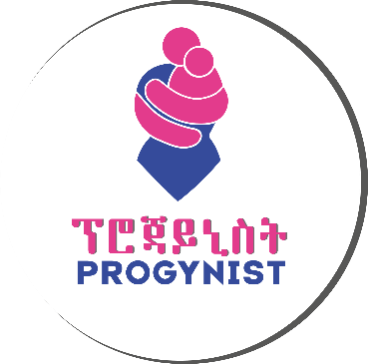

Program I

USAID/ETHIOPIA Family-Focused HIV prevention, care and treatment services

Executive Summary
Progynist has made excellent strides towards combatting gender-based violence with sexual violence prevention interventions and several awareness campaigns. It continually made efforts to strengthen the capacity, collaboration, and commitment of others to increase gender equality. It made primary duty bearers at the forefront of gender and gender-based violence interventions.
Continuing throughout the year 2022, Progynist implemented community-based HIV services program through partnerships with local authorities and by mobilizing community resources to improve the lives of HIV affected orphan and vulnerable children and their adult caregivers. Progynist has also been working towards the enhancement of the response of communities to violations of rights of women and girls by especially addressing gender-based violence.
Acronyms
AGYW Adolescent Girls and Young Women
ART Anti-Retroviral Treatment
ARV Anti-Retroviral Viral
BoWCA Bureau of Women and Children Affairs
CAG Community ART Refill Group
CBO Community Based Organization
CC Community Committee
CCC Community Care Coalition
CEF Community Engagement Facilitator
CG Care Giver
CRP Community Resource Person
CW Case Worker
DSD Direct Service Delivery
DSDM Differentiated Service Delivery Model
FBO Faith Based Organization
FP: Family Planning
FSW Female Sexual Worker
GBV Gender Based Violence
HAPCO HIV/AIDS Prevention and Control Office
HCT HIV Counseling and Testing
HF Health Facility
HIVST HIV Self-Test
HTC HIV Testing Counseling
HTS HIV Testing Services
ICT Index Case Testing
KP Key Population
OVC: Orphan and Vulnerable Children
PEPFAR Presidents Emergency Plan for AIDS Relief
PLHIV People Living With HIV
SNNPR: Southern Nation Nationalities People Region
SNU Sub National Unit
SOP Standard Operational Procedure
SSW Social Service Workers
TOT Training of Trainers
TX_CURR Currently Receiving Antiretroviral Therapy
VL Viral Load
VLS Viral Load Suppression
WCYAs Women, Children and Youth Affairs
WROs Women Rights Organizations
Bi-annual performance of the program
Progynist operates in Addis Ababa, Guraghe zone in Butajira, Hadiya zone in Hosaena and Bench-sheko zone in Mizan Aman of the newly formed South-west region. It has successfully expanded into the Sheka zone, Tepi town to implement the Family-focused HIV prevention, care and treatment services program.
Project Name | Period of Activity | Annual Budget (ETB) | Program Status | Project site/s
USAID/ETHIOPIA Family-Focused HIV prevention, care and treatment services | January 1, 2022 – December 31, 2022 | 19,814,678.98 | Ongoing | - Butajira  - Hosanna  - MizanAman  - Bonga  - Tepi

Program Description for year II
The project is funded by United States Agency for International Development (USAID)/Ethiopia. Progynist signed an agreement with the donor to implement the program for three years with a total budget of 15,033,347.50 birr.
The project is designed to achieve two broad-spectrum results i.e., increased access & demand to family-focused HIV services that reduce HIV incidence in the community and Strengthened utilization of data to monitor service delivery and conduct quality improvement of program services. Progynist, as a local implementing partner (LIP), will implement Family-Focused HIV Prevention, Care and Treatment Services in SNNPR in Guraghe zone at Butajira, Hadiya zone at Hosaena, Bench Sheko zone at MizanAman and Sheka zone at Tepi towns to address the needs of 7589 orphan and vulnerable children of 1295 KPs and PPs adult care givers. Progynist will reach all target project geographic areas, target families and communities with intended services.
  - Goal, objectives
- The overall goal of this project is by 2023, to reinforce and revolutionize the multi-sectors and multi-stakeholder responses of HIV epidemic control at Butajira& Hosanna at SNNPR and Mizan & Tepi at South-west Region.
  - General Objective:
- To improve the lives of 7987 orphan and vulnerable children by increasing access & demand to Family-focused HIV services that reduce HIV incidence in the community.
  - Specific objectives:
- To contribute to the attainment of HIV epidemic control within the target SNUs by 2023.
- To strengthen utilization of data of the 9279 beneficiaries to monitor service delivery while applying continuous quality improvement of program services every year until 2023.

Implementation Strategies
    - Operation Triple Zero: To achieve this purpose, the project will ensure that the targeted SNUs, Woreda Health bureaus and Health Facilities, community structures, CCC, FBOs CBOs and stakeholders have the capacity to facilitate high quality HIV/AIDS related services for HIV impacted OVC tailored to addressing TRIPLE ZERO approach namely: Zero missed appointments, zero missed medications, zero viral load, zero infections 9-14 to contribute to national 95/95/95 goal. The OTZ (Operation Triple Zero) interventions will be used to reach all children/adolescents with HIV. Progynist will facilitate PLHIV support group /OTZ club/ at Butajira, Hosaena and Mizan Aman.
    - Accelerating community-based ART: Progynist will enhance acceleration of community-based ART to full implementation in all project areas and significantly reduce patient loads at health facilities, especially during COVID-19pandemic conditions. To do this, we will advocate and lobby the health sectors in the targeted SNUs on strengthening and expanding the implementation of the 6 months multi-month dispensing (MMD) and introduce health worker managed Community ART refill Groups (CAG) and promote fast track pharmacy refill at the three targeted SNUs.
    - Realigning OVC program to HIV treatment program: OVC/C&T will use case management standard procedures to assess needs and deliver family focused integrated services for targeted OVC sub-populations including HIV+ children, adolescents and children of HIV+ mothers. The project will prioritize fostering facility and community-based Index Case testing of KPs and PPs adults and their biological children by tracking them in the community and providing professional assisted self-testing. Currently, Progynist has MOUs with health facilities, CC/CCC in targeted SNUs that will be utilized and updated in the context of this project. There are several community cadres the partners are already working with including SSWs, Case Workers, health facility professionals and health extension workers.

    - Focused HIV testing and linkage for newly diagnosed cases in the community: Approaches include user friendly services for adolescents, facilitating separate space and scheduling for clients with high viral load, establishment and facilitation of Facility-Community collaboration for case identification, adherence support and tracing of lost clients. Health facilities and providers will be capacitated to address the demands and needs of those who might be displaced or self-transferred.
    - Delivering differentiated service package for pediatric, adolescent and adult ART clients to improve retention, adherence and viral load suppression: HIV/ART literacy education to caregivers on HIV/ART, Disclosure support for caregivers so children/adolescents with HIV infection are disclosed of their HIV status, HIV/ART literacy education to adolescents with HIV through peer-led group support.
    - As innovative approach Progynist deploys U = U initiative which includes one to-one peer support for newly initiated patients and those with high viral load. The strategies include reinforcing interface between community and facility-based actors; improving documentation of patient demographics; engaging FBOs as program advocates and ensuring messaging that is consistent and aligned with evidence-based approaches for HIV case identification, treatment of HIV and co-morbidities, and at the same time respecting and adhering to social and religious values among the community. Additional strategies include ongoing bring back-to-treatment periodic campaigns. The following tools will be used to ensure proper adherence assessment and support is provided for each infected child/adolescent: Appointment calendar to track ART and viral load testing dates and send reminders ahead of time, Scripted adherence counseling guide to provide proper support and identify adherence barriers ahead of time before a problem arises, Adherence barrier analysis and support for clients who are LTFU, have missed appointment, missed dose, or high viral load. For clients with high viral load, enhanced adherence counseling and support will be provided.
    - Primary prevention for HIV and violence among 9-14-year-old: We will use the PEPFAR approved curriculum of IMpower and Sinovuyo Teens. We will work with the curriculum developers to complete the ongoing TOTs to build capacity of our trainers and scale up reach to adolescents and their families and communities with the curriculum interventions.
    - Supporting risk and needs assessment of beneficiaries encountered by the program or served by collaborating agencies to mitigate risk of HIV acquisition, ART retention and adherence barriers to improve viral load suppression. A risk assessment tool will be systematically applied to all identified at risk children, youth and adults with unknown HIV status in all the target SNUs to determine which of them need to be tested.
    - Quality improvement approach: Two models will be used to address gaps in quality in ICT and viral suppression cascade. Training will be provided to project staff based on FHI360’s quality improvement model using Plan Do Study Act (PDSA) cycle.
    - Cross cutting themes: Progynist will work to addressing HIV and gender equitable HIV prevention, care, treatment and support to promote positive gender norms; Gender-based violence prevention and care services for beneficiaries identified by the program including post-GBV care; and increase gender equitable access to income and productive resources, including education and health care.
    - HIV and COVID-19: The project implementation will give due attention to reduce the transmission of COVID-19 which might be the additional burden of HIV through protecting front line health workers and technical staff of the project using USAID guide lines and principles that will enable us to protect the gains of thus far efforts on HIV responses.

Program Performance

Result 1: Increased access & demand to family-focused HIV services that reduce HIV incidence in the community

Intermediate Result 1.1: HIV testing and counselling in the targeted SNUs increased.
- During the year 2022, Progynist provided HIV testing and counseling services to a total of 2391 clients, 1301 (54%) females and 1090 (46%) male clients/contacts of HIV positives at Mizan, Tepi, Butajira and Hosanna sites.
- Progynist identified a total of 187 (113 female and 74 male) HIV positives, 38 at Butajira, 35 at Hossana, 73 at Mizan and 41 at Tepi sites through index case testing strategy. Most of the identified cases were spousal/non-spousal contacts of HIV positive index cases. All 187 (100%) of them were linked to health facilities for counseling and initiation of anti-retroviral treatment.
- Progynist provided Unassisted/Assisted self-testing options to clients who preferred that option instead the traditional conventional testing by the provider. During the year 246 kits were provided at all sites where 139 (57%) were for female clients and the rest 107 (43%) were male. Through this approach, 14 HIV positives were reported, which were confirmed by our service providers.
- Purchased and provided HTS commodities such as safety boxes, 30 boxes of examination gloves, cotton packs, 70% alcohol and 400 lancets to support testing functions. HIV testing kits, condoms and COVID-19 prevention hand washing equipment were provided by the prime partner Mary joy Ethiopia in collaboration with Project Hope, PSI and PFSA at all sites.
Intermediate Result 1.2: HIV retention and adherence services improved
- Monthly QI meetings conducted at the four towns with team composition of focal personnel from Health facilities, woreda/town level health departments, Progynist’s community engagement facilitators, and other relevant government signatory offices.
- Quarterly consultative meetings with potential service providers, FBOs, CCCs, and CBOs to establish smooth referral linkage for PLHIVs was conducted at all implementation towns.
- Provided need-based community care and support services to 653 (75%) clients in the community level with services that include routine adherence counseling and continuity of treatment, psychosocial services, screening for mental health, STI, and TB and services for community-based NAC.
- Re-engagement of HIV positive clients on ART that were lost from treatment: during the year we were able to re-engage a total 156 clients who were lost from treatment. (30 at Butajira, 26 at Hosanna, 58 at Mizan, and 42 at Tepi)
- Provided interventional adherence counseling service to 155 clients with poor adherence. Counseling mainly focused on drug side effects, positive and healthy living practice, and drug adherence.
- Cervical ca screening and treatment demand creation was provided to 832 WLHIVs through 8 CEFs and 36 CRPs in collaboration with PLHIV associations to enhance accurate sensitization to cervical cancer and the necessity of screening and treatment, and reduce stigma among WLHIVs.
- Progynist provided cervical cancer (CxCa) screening and referral services to 68 PLHIVs. Out of the 36 referred cases, 5 of them tested positive for the cancer test. The rest were negative.
- The implementation towns provided GBV screening, referral and support for 271 (100%) clients to access local clinical (e.g., STI, FP, MCH, etc.) and non-clinical services (e.g., longer-term psychosocial support, shelter services, economic empowerment activities, etc.) that will assist with continued recovery. A total of 11 WLHIVs disclosed a history of GBV that occurred to them within the last three months. They were eventually referred to health facilities for clinical post-violence care.
Intermediate Result 1.3: Mitigation of OVC programming: Comprehensive OVC & Primary prevention.
- Aimed at successful and quality service delivery, Progynist facilitated Coordination of care refresher training for 15 selected Kebele CCC members, 235 volunteer case workers and 11 social service workers for an improved implementation of OVC service delivery at all implementation towns.
- Provided home-to-home care and support services for 4409 OVC and their 1113 care givers as per the identified needs and developed care plan. We mobilized CWs to provide services to enrolled clients in the OVC comprehensive Program.
- During the reporting period, Case Workers provided comprehensive services for CGs and OVCs, who are in comprehensive services, during home-to-home visits.
  - Provided disclosure support counseling to 107 OVCs and their 332 caregivers;
  - Provided referral to civil registration services for 270 OVC,
  - Provision of hygiene counseling and WASH messaging for 1425 OVCs,
  - Educational counseling on importance of education, attendance, performance was provided to 1701 OVCs and their caregivers through home visits by SSWs and CWs.
- Business Development support (BDS) and Selection, Planning and Management (SPM) training was provided to 123 care givers of OVCs.
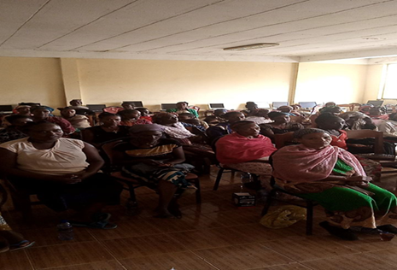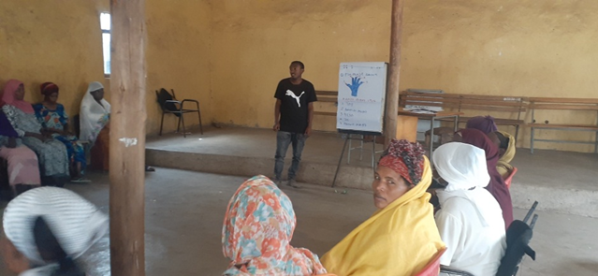
Business Development Skills training at Mizan (on the left) and Butajira (on the right), April 2022
- Financial capability training which focuses on combination of attitude, knowledge, skills, and self-efficiency needed to make and exercise money management decisions that best fit the circumstances of one’s life was provided to 123 caregivers of OVCs.
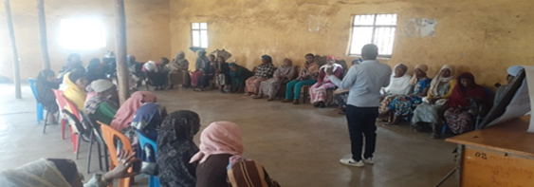
Financial Capability training at Butajira town, April 2022
- After conducting needs and market assessments at all target towns, Progynist facilitated the purchased and delivered assets to 275 households located at Butajira, Hosanna and Mizan, households who are classified as destitute based on their uniquely identified needs to achieve economic productivity.

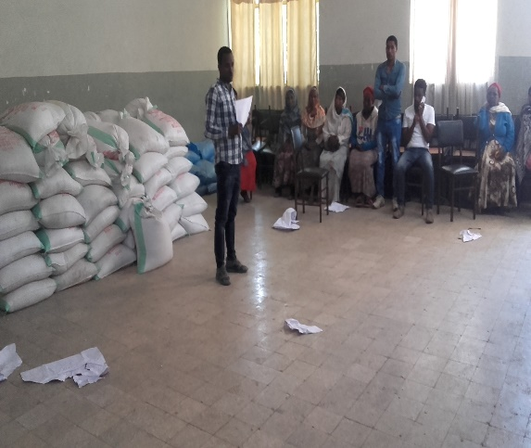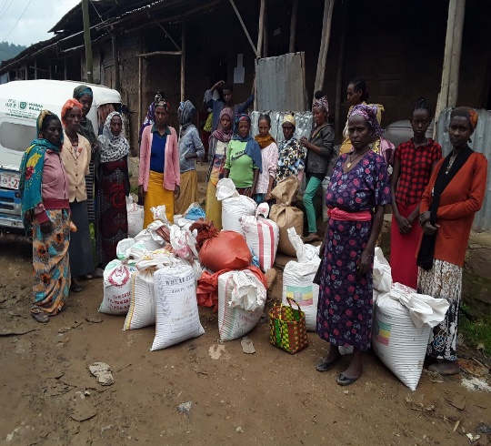
Asset transfer to destitute Households at Butajira (on the left) and at Mizan (on the right), March 2022
- Established Village Savings and Loans (VSLA) Groups and provide 3 days VSLA training 41 VSLA groups National ES guideline.

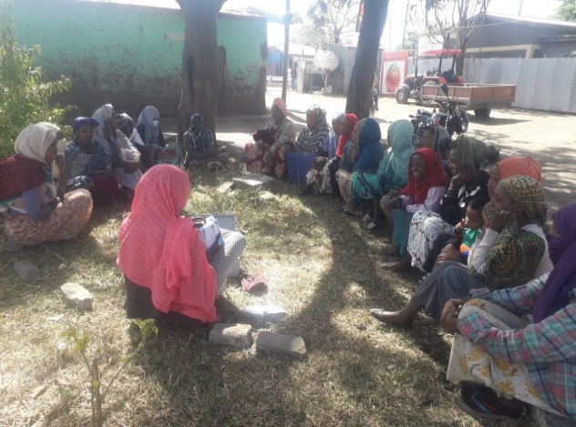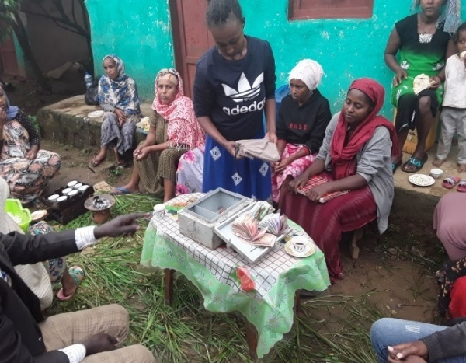
VSLA groups at Butajira (on the left) and at Mizan (on the right), February 2022
- Provided IMPOWER-IMSAFER curriculum-based violence prevention training to 1608 girls 9-14 years for a total12 hours which is 3 hours per session.
- 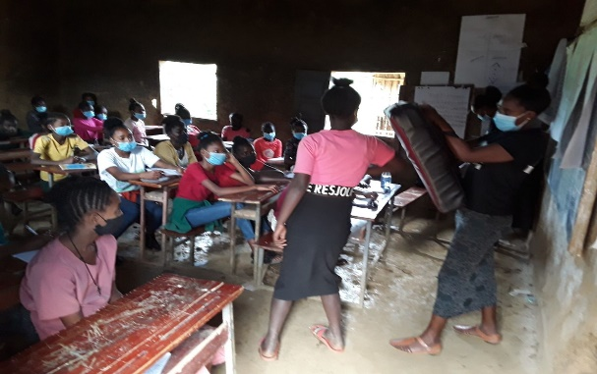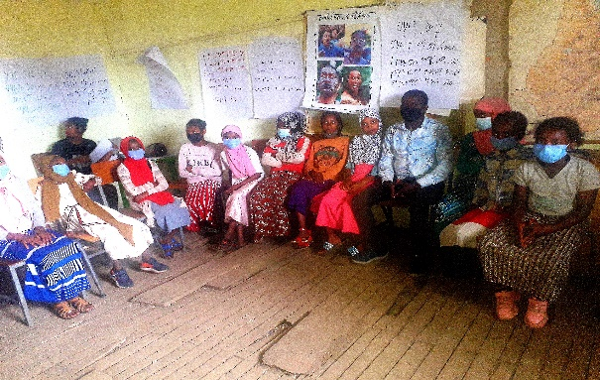
Impower-IMsafer training at Hosanna (on the left) and at Mizan (on the right), March 2022
- Provided Sinovuyo (parenting training) to 494 OVCs and their care givers at Butajira, Hosanna and Mizan for a total of 3-days.
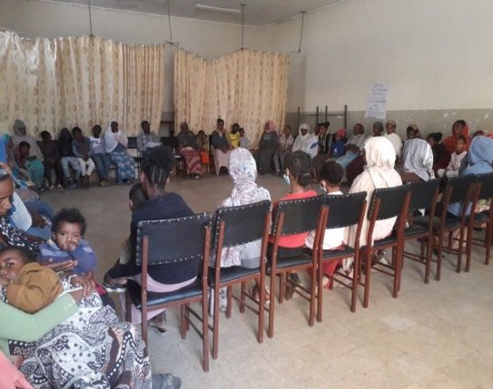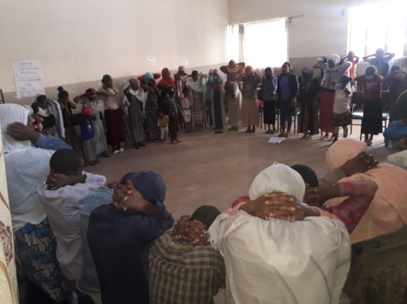
Sinovuyo training at Butajira (on the left) and at Hosanna (on the right), February-March 2022

- Provided coaching boys into men (CBIM) training to 739 9–14-year-old boys at school venues. This training is provided to create awareness for all boys in the school and to let them know and practice gender equality It helps them to respect adolescent girls and safeguard them from any form of sexual violence.
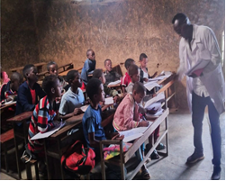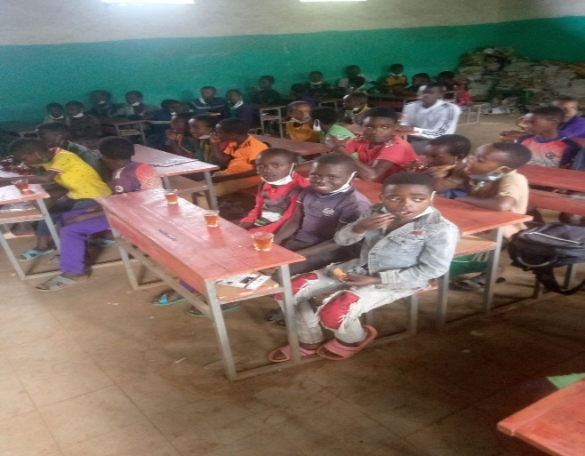
CBIM training to 9-14-year-olds at school venues in Mizan town, March 2022
- Conducted performance review meeting with all project partners at zone and woreda level at the implementation towns. Representatives of WCYA, BoLSA, BOH, BOFED, BOE, and community groups, and delegates of Health facilities participated. The purpose of the meetings was to review quarterly based performance at each implementation which evaluates plan vs achievement on Program indicators.
- To resolve data quality issues especially consistency between source documents and reports, all towns implemented Quarterly based Routine data quality assessment (RDQA) on the project indicators.
- Developed and implemented Quality improvement projects across all towns; The sample run chart below shows Mizan town’s project to improve community differentiated service delivery model implementation
- 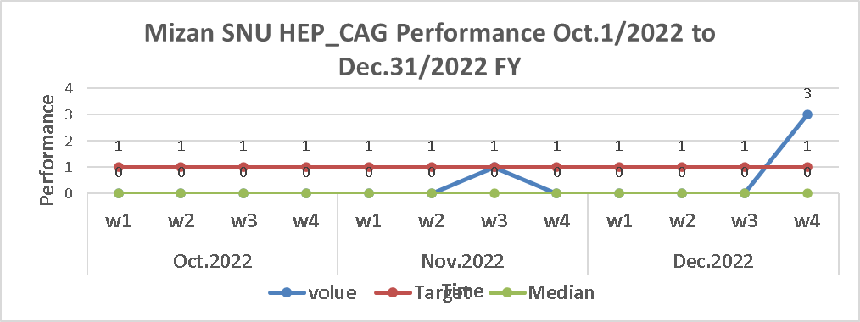

Major Challenges and Actions
Major challenges
- Work over load on some program staff due to delays in recruitment of additional staff.
- Issues with ART providers regarding DSDM implementation at some HFs who are forcing clients to options other than community DSDM options.
- HIV testing Line lists received were out of our catchment areas and some clients relocated.
- Inadequate contact elicitation
- Some Lost to follow-up clients address was wrongly filled and had no phone numbers.
- Shortage of HIV test kits, especially SD kits

- Absence of vehicle for Butajira coordination office which makes it difficult to provide timely support to Hosanna town.
Actions taken
- Staff collaboration to share work load, and outsourcing data encoding activities to temporary data encoders.
- Conducted performance review discussions with association and town health office to resolve the issues and reach consensus.
- Implemented volunteer motivation mechanisms and reviewed Weekly performance review/evaluation of community service providers.
- Consensus building meeting with the hospital medical director, and LIP leaders was conducted at Tepi. Direction from the Hospital management was set; follow-up meetings were conducted to ensure it was resolved.
- Improved community HIV care and treatment transportation and travel allocation to alleviate the problem until Mary Joy/USAID responds to our request.

Program Success Story:
“A smile of Hope”
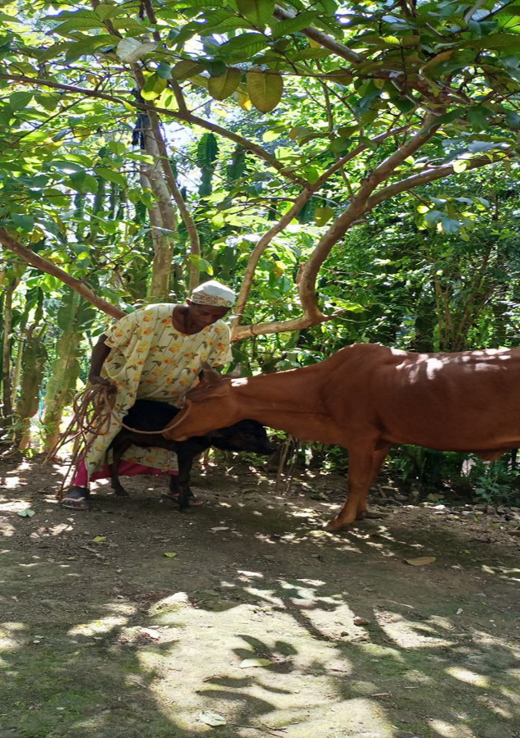

Wuda Gebra is a 38-year-old woman living in Ambassador village of Mizan Aman Town. She has two children, and is a known HIV positive woman on ART for the last seven years. Her husband died five years ago making her the head of her household. In the periods after the death of her husband, she faced financial difficulties to cover basic household items and educational materials of her children. The PLHIV association in her vicinity provided support to her but it was not sufficient to meet the needs of the household.
Under the family-focused HIV prevention, care and treatment services activity, Wuba was enrolled into the OVC program by Progynist’s social workers. After a thorough economic vulnerability assessment, Wuda was shortlisted for the Assets transfer activity supporting destitute households. Capitalizing on her household’s strengths, assets of teff and rice 42 kilogram and 40 kilograms were provided, which she is using to sell Enjera, generating income that helps her meet her family’s needs. Additionally, she joined her communities saving group “ekub” which helped her save up to 27,000 ETB. She bought a cow that she uses to extract milk from its udders and sells to local cafes and hotels. The investment now generates additional 1000 ETB per day to her household. “Now my children smile with hope...” says Wuba, looking at her children, grateful of the opportunities made available to her. Nowadays, Wuda’s living situation has significantly improved, with a path to all-round economic success all but assured.

