Annual Performance Report (January 1, 2021 – December 31, 2021)

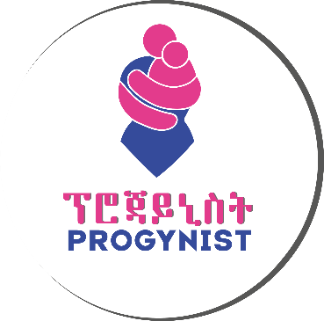

Executive Summary

Progynist is an indigenous ‘pro-women’ civil society organization established in April, 1997. Since
then, it has been committed to making a positive difference in the lives of Women and Children.
Progynist has been making excellent strides towards combatting gender-based violence with sexual violence prevention interventions and several awareness campaigns. It continually made efforts to strengthen the capacity, collaboration, and commitment of others to increase gender equality. It made primary duty bearers at the forefront of gender and gender-based violence interventions. Implementation strategies are continually re-designed to mitigate the effects of the COVID-19 pandemic.
Progynist’s programs in the year 2021 brought a tried and tested community-based HIV services approach through partnership with local authorities by mobilizing community resources to improve the lives of HIV affected orphan and vulnerable children and their adult care givers. In turn it is working towards to the attainment of HIV epidemic control within the four towns in SNNPR. Progynist has also been working towards the enhancement of the response of communities to violations of rights of women and girls by especially addressing gender-based violence.
Table of Contents
Executive Summary 1
Acronyms 2
Performance in the year 2020 (January 1, 2021 – December 31, 2021) 4
1. USAID/ETHIOPIA Family-Focused HIV prevention, care and treatment services 0
1.1. Program Description 0
1.2. Objectives 0
1.3. Implementation Strategies 0
1.4. Program Performance 3

Acronyms
AGYW Adolescent Girls and Young Women
ART Anti-Retroviral Treatment
ARV Anti-Retroviral Viral
BoWCA Bureau of Women and Children Affairs
CAG Community ART Refill
CBO Community Based Organization
CC Community Committee
CCC Community Care Coalition
CEF Community Engagement Facilitator
CG Care Giver
COP Country Operational Plan
CRP Community Resource Person
CW Case Worker
DSD Direct Service Delivery
DSDM Differentiated Service Delivery Model
EDHS Ethiopian Demographic Health Survey
FBO Faith Based Organization
FP: Family Planning
FSW Female Sexual Worker
HAPCO HIV/AIDS Prevention and Control Office
HCT HIV Counseling and Testing
HF Health Facility
HIVST HIV Self-Test
HTC HIV Testing Counseling
HTS HIV Testing Services
ICT Index Case Testing
IGA Income Generation Activity
IPTT Indicator Performance Tracking Tool
KP Key Population
MJE Mary Joy Ethiopia
OVC: Orphan and Vulnerable Children
PEPFAR Presidents Emergency Plan for AIDS Relief
PLHIV People Living With HIV
PMP Performance Monitoring Plan
PP Priority Population
SNNPR: Southern Nation Nationalities People Region
SNU Sub National Unit
SOP Standard Operational Procedure
SSW Social Service Workers
TA Technical Assistance
TOT Training of Trainers
TX_CURR Currently Receiving Antiretroviral Therapy
UNAIDS United Nations Program on HIV and AIDS
VL Viral Load
VLS Viral Load Suppression

Performance in the year 2020 (January 1, 2021 – December 31, 2021)
Progynist continued to operate in Addis Ababa, Guraghe zone in Butajira, Hadiya zone in Hosaena and Bench-sheko zone in Mizan Aman of the newly formed South-west region. It has successfully expanded into the Sheka zone, Tepi town to implement the Family-focused HIV prevention, care and treatment services program.
Project Name | Period of Activity | Annual Budget (ETB) | Program Status | Project site/s
- Civil Society Support Program Phase II (CSSP2) - Beyond Numbers:
- PIE Leveraging Women’s Potential for Maintaining & Sustaining Peace
- USAID/ETHIOPIA Family-Focused HIV prevention, care and treatment services | January 1, 2020 – December 31, 2021 | 13,270,846.50 | Ongoing | - Butajira  - Hosanna  - Mizan Aman  - Tepi

USAID/ETHIOPIA Family-Focused HIV prevention, care and treatment services

Program Description
The project is funded by United States Agency for International Development (USAID)/Ethiopia. Progynist signed an agreement with the donor to implement the program for three years with a total budget of 11,353,946.45 birr.
The project is designed to achieve two broad spectrum results i.e. Increased access & demand to family-focused HIV services that reduce HIV incidence in the community and Strengthened utilization of data to monitor service delivery and conduct quality improvement of program services. Progynist, as a local implementing partner (LIP), will implement Family-Focused HIV Prevention, Care and Treatment Services in SNNPR in Guraghe zone at Butajira, Hadiya zone at Hosaena, Bench Sheko zone at Mizan Aman and Sheka zone at Tepi towns to address the needs of 7589 orphan and vulnerable children of 1295 KPs and PPs adult care givers. Progynist will reach all target project geographic areas, target families and communities with intended services.

Objectives
- The overall goal of this project is by 2023, to reinforce and revolutionize the multi-sectors and multi-stakeholder responses of HIV epidemic control at Butajira & Hosanna at SNNPR and Mizan & Tepi at South-west Region.
General Objective:
- To improve the lives of 7987 orphan and vulnerable children by increasing access & demand to Family-focused HIV services that reduce HIV incidence in the community.
Specific objectives:
- To contribute to the attainment of HIV epidemic control within the target SNUs by 2023.
- To strengthen utilization of data of the 9279 beneficiaries to monitor service delivery while applying continuous quality improvement of program services every year until 2023.

Implementation Strategies
- Operation Triple Zero: To achieve this purpose, the project will ensure that the targeted SNUs, Woreda Health bureaus and Health Facilities, community structures, CCC, FBOs CBOs and stakeholders have the capacity to facilitate high quality HIV/AIDS related services for HIV impacted OVC tailored to addressing TRIPLE ZERO approach namely: Zero missed appointments, Zero missed medications, Zero viral load, Zero infections 9-14 to contribute to national 95/95/95 goal. The OTZ (Operation Triple Zero) interventions will be used to reach all children/adolescents with HIV. Progynist will facilitate PLHIV support group /OTZ club/ at Butajira, Hosaena and Mizan Aman.
- Accelerating community-based ART: Progynist will enhance acceleration of community-based ART to full implementation in all project areas and significantly reduce patient loads at health facilities, especially during COVID-19 pandemic conditions. To do this, we will advocate and lobby the health sectors in the targeted SNUs on strengthening and expanding the implementation of the 6 months multi-month dispensing (MMD) and introduce health worker managed Community ART refill Groups (CAG) and promote fast track pharmacy refill at the three targeted SNUs.
- Realigning OVC program to HIV treatment program: OVC/C&T will use case management standard procedures to assess needs and deliver family focused integrated services for targeted OVC sub-populations including HIV+ children, adolescents and children of HIV+ mothers. The project will prioritize fostering facility and community-based Index Case testing of KPs and PPs adults and their biological children by tracking them in the community and providing professional assisted self-testing. Currently, Progynist has MOUs with health facilities, CC/CCC in targeted SNUs that will be utilized and updated in the context of this project. There are several community cadres the partners are already working with including SSWs, Case Workers, health facility professionals and health extension workers.
- Focused HIV testing and linkage for newly diagnosed cases in the community: Approaches include user friendly services for adolescents, facilitating separate space and scheduling for clients with high viral load, establishment and facilitation of Facility-Community collaboration for case identification, adherence support and tracing of lost clients. Health facilities and providers will be capacitated to address the demands and needs of those who might be displaced or self-transferred.
- Delivering differentiated service package for pediatric, adolescent and adult ART
clients to improve retention, adherence and viral load suppression: HIV/ART literacy education to caregivers on HIV/ART, Disclosure support for caregivers so children/adolescents with HIV infection are disclosed of their HIV status, HIV/ART literacy education to adolescents with HIV through peer-led group support.
- As innovative approach Progynist deploys U = U initiative which includes one to-one peer support for newly-initiated patients and those with high viral load. The strategies include reinforcing interface between community and facility-based actors; improving documentation of patient demographics; engaging FBOs as program advocates and ensuring messaging that is consistent and aligned with evidence-based approaches for HIV case identification, treatment of HIV and co-morbidities, and at the same time respecting and adhering to social and religious values among the community. Additional strategies include ongoing bring back-to-treatment periodic campaigns. The following tools will be used to ensure proper adherence assessment and support is provided for each infected child/adolescent: Appointment calendar to track ART and viral load testing dates and send reminders ahead of time, Scripted adherence counseling guide to provide proper support and identify adherence barriers ahead of time before a problem arises, Adherence barrier analysis and support for clients who are LTFU, have missed appointment, missed dose, or high viral load. For clients with high viral load, enhanced adherence counseling and support will be provided.
- Primary prevention for HIV and violence among 9-14-year-old: We will use the PEPFAR approved curriculum of IMpower and Sinovuyo Teens. We will work with the curriculum developers to complete the ongoing TOTs to build capacity of our trainers and scale up reach to adolescents and their families and communities with the curriculum interventions.
- Supporting risk and needs assessment of beneficiaries encountered by the program or served by collaborating agencies to mitigate risk of HIV acquisition, ART retention and adherence barriers to improve viral load suppression. A risk assessment tool will be systematically applied to all identified at risk children, youth and adults with unknown HIV status in all the target SNUs to determine which of them need to be tested.
- Quality improvement approach: Two models will be used to address gaps in quality in ICT and viral suppression cascade. Training will be provided to project staff based on FHI360’s quality improvement model using Plan Do Study Act (PDSA) cycle.
- Cross cutting themes: Progynist will work to addressing HIV and gender equitable HIV prevention, care, treatment and support to promote positive gender norms; Gender-based violence prevention and care services for beneficiaries identified by the program including post-GBV care; and increase gender equitable access to income and productive resources, including education and health care.
- HIV and COVID-19: The project implementation will give due attention to reduce the transmission of COVID-19 which might be the additional burden of HIV through protecting front line health workers and technical staff of the project using USAID guide lines and principles that will enable us to protect the gains of thus far efforts on HIV responses.

Program Performance

Result 1: Increased access & demand to family-focused HIV services that reduce HIV incidence in the community
Intermediate Result 1.1: HIV testing and counselling in the targeted SNUs increased.
- During the year 2021, Progynist provided HIV testing and counseling services to a total of 1074 clients, 598 female and 476 male clients/contacts of HIV positives at Mizan, Tepi, Butajira and Hosanna sites.
- Progynist identified a total of 42 (34 female and 8 male) HIV positives, 3 new HIV positives at Butajira, 5 at Hosanna, 25 newly diagnosed HIV positives at Mizan and 9 at Tepi sites through index case testing strategy. Most of the identified cases were spousal/non-spousal contacts of HIV positive index cases. All 42 (100%) of them were linked to health facilities for counseling and initiation of anti-retroviral treatment.
- Progynist provided Unassisted/Assisted self-testing options to clients who preferred that option instead the traditional conventional testing by the provider. During the year 59 test kits were provided at all sites where 33 (47%) were for female clients and the rest were male. Through this approach, 4 HIV positives were reported, which were confirmed by our services providers respectively.
- A 7-days comprehensive training to health service providers on Index case testing SOP, testing algorithms, counseling skills and GBV screening and response was provided in collaboration with our partners. The certified health providers trained 117 case workers engaged in the implementation of the community-based HIV testing at all sites.
- Provided a half-day orientation on HIV disclosure and other HIV/health issues to 117 case workers engaged in the implementation of the community-based HIV testing.
- Organized experience sharing meeting among members of health facilities to address the issues of OVCs. The meeting was helpful to let the participants know how the project clients were selected and enrolled to the program. It was organized among 18 members of health facilities in Butajira,12 members of health facilities in Hossana and at the same time it was done in Mizan Aman to improve management of OVC issues including identification, enrollment and bi-directional referral system.
- Purchased and provided HTS commodities such as 43 safety boxes, 15 boxes of examination gloves, 283 cotton packs and 140 bottles of alcohols. HIV testing kits, condoms and COVID-19 prevention hand washing equipment were provided by the prime partner Mary joy Ethiopia in collaboration with Project Hope, PSI and PFSA at all sites.
- Facilitated community dialogue sessions with the participation of 105 community members at each service delivery site that included CCCs, caregivers, local leaders, and youth groups to raise awareness on HIV self-testing and to increase demand and access for HIV testing.
Intermediate Result 1.2: HIV retention and adherence services improved
- Progynist recruited 36 Community resource persons (CRPs) or PLHIV volunteers to facilitate the community-based testing and provide community level care and support services to stable PLHIV clients enrolled to the program.
- Along with 4 health facility case managers, all the CRPs received training community care and support services.
- As part of the comprehensive care and treatment services, during the year 2021, Interventional adherence counseling support was provided to 126 PLHIVs at Butajira, 202 at Hosaena ,158 at Mizan Aman and 133 at Tepi who are PLHIVs with poor adherence.
- A total of 59 clients received GBV screening and referral services 4 were at Butajira, 54 at Hosaena and 5 at Tepi.
- Cervical cancer testing demand creation activities in the form of counseling in association with CRPs was provided to 700 clients (120 at Butajira, 180 at Hosaena, 164 at Mizan and 236 at Tepi)
- Progynist provided Cervical cancer (CxCa) screening and referral services to 148 PLHIVs (23 at Butajira, 28 at Hosaena, 48 at Mizan and 49 at Tepi). 11 clients (9 from Mizan, 4 from Tepi) tested positive for the cancer test. The rest were negative.
- A community sensitization event for one day was conducted to introduce community ART distribution models CAG/CARD involving PLHIVs and other stake holders in the target towns.
- A community wide event focusing on ART retention and viral load suppression was organized in Hosanna in collaboration with 21 individuals from different kebeles. The event provided a variety of teaching and entertaining programs.
Intermediate Result 1.3: Mitigation of OVC programming: Comprehensive OVC & Primary prevention.
- During the year 2021, a total of 7589 OVCs and their adult CGs, 2096 at Butajira, 1800 at Hosanna and 3693 at Mizan towns received food and/or other services, shelter and care, education or vocational training, protection and legal aid services as well as economic strengthening Services and the majority received health care and referral and eligible adults and children provided with psychological, social, or spiritual support services during the reporting period.
- Case Workers provided comprehensive services for CGs and OVCs through home to visits: Among the services
  - 36 OVCs were successfully linked to academic support.
  - Educational counseling on importance of education, attendance, performance was provided to 97 OVCs and their caregivers in Butajira, to 775 OVCs in Hosanna and 1047 OVC in Mizan town.
  - Provided disclosure support for 412 OVCs
  - Provision of hygiene counseling and WASH messaging for 510 OVCs,
  - Completed link to age-appropriate HIV literacy education for 449 OVCs and 104 CGs;
  - Provided age and gender sensitive HIV prevention education and sexual risk avoidance intervention for 320 adolescent OVCs
  - Provided linkage to immunization services for 9 OVCs;
  - Linked 4 caregivers to small business support services,
  - Linked 39 households to government social protection;
  - Linked 313 households to savings groups;
  - Provided disclosure support for 164 CGs;
  - Provision of hygiene counseling and WASH messaging for 189 CGs,
  - Provided age-appropriate ART adherence counseling for 97 CGs.
- Procured and distributed PPEs (Face masks and sanitary materials) for COVID 19 mitigation to 36 CRPs, 190CWs, 10 SSWs, and 28 project staff across all service delivery sites to ensure COVID-19 safe environment.
- Organized bi-annual experience sharing meeting among health facility Members, to improve management of OVC issues including identification, bi directional referral, viral load suppression, monitoring, management of sexual violence within the service delivery site.
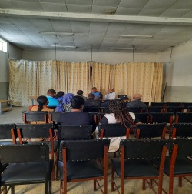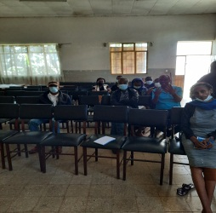
Bi-annual Experience sharing meeting with health facilities at Butajira town, April 2021

- Provided scholastic material support for 60 destitute OVCs in Butajira, 120 in Hosanna and 120 in Mizan town for the new school year.
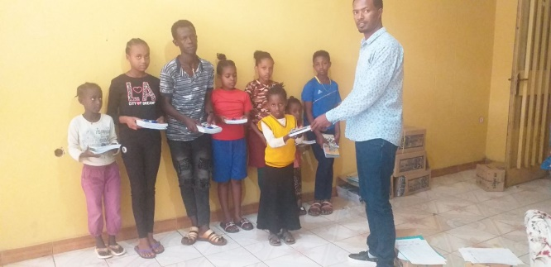
Provision of scholastic materials to OVCs at Mizan town, August 2021

- After conducting needs and market assessments at all target towns, Progynist facilitated the purchased and delivered assets to 67 households at Butajira, 86 households at Hosanna, and 79 households classified as destitute based on their uniquely identified needs to achieve economic productivity.
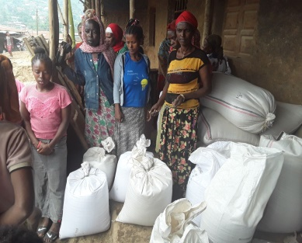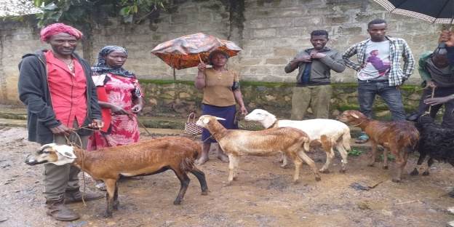
Asset transfer support to destitute households at Mizan town, March-April 2021 (partial view)

- A 3-days financial capability training was provided to 44 CGs in Butajira, 10 CGs in Hosanna and 31 CGs in Mizan Aman using USAID/FHI ASPIRE curriculum.
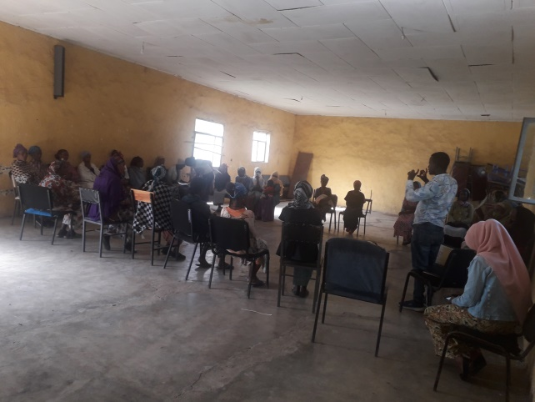
Financial capability training for caregivers at Butajira town, April 2021 (partial view)
- Provided a 3-days 4-hour session financial capability training to 40 female sexual workers (FSWs) in Butajira, for 10 FSWs in Hosanna and to 20 FSWs in Mizan.
- Provided IMPOWER-IMSAFER training (a curriculum-based HIV and sexual violence prevention training) to 1088 9–14-year-old girls at Butajira, Hosanna, and Mizan in collaboration with NMNW/FHI360.
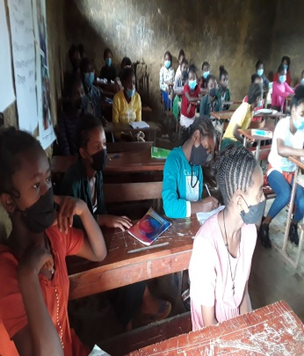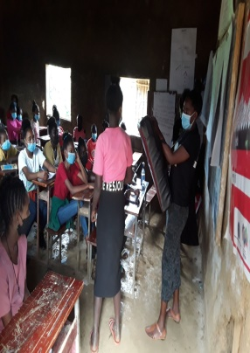
Impower/IMsafer training at Mizan site, June 2021 (partial view)
- Provided Sinovuyo (Parenting training) to 280 9-14 boys and girls and their caregivers (145 male and 135 girls) at the three implementation towns.
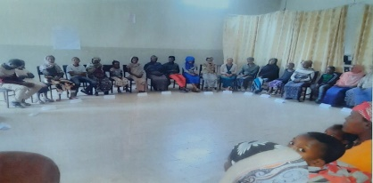
Sinovuyo training at Butajira town, March 2021 (partial view)
- Coaching boys into men (CBIM) training was provided to 1140 9–14-year-old boys using trained and certified sport teachers at the three implementation towns.
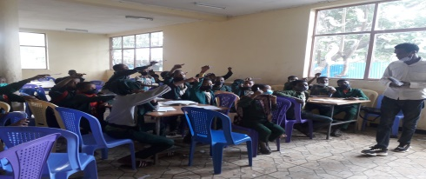
CBIM training to 9-14-year-old boys at Mizan town, March 2021 (partial view)
- Quarterly performance review meetings were conducted after the quarter reporting period with representatives of project partners (WCA, BoLSA, BOH, BOFED, BOE at zone and woreda level, and community groups) at the three implementation towns.
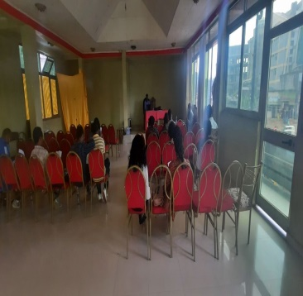
Performance review meeting at Mizan town, April 2021 (partial view)
- All implementation towns conducted routine data verification and data quality assurance to ensure report and available source document consistency.

